The Order of Worship April 18, 2021
Lutheran Service Book Setting 3
The Third Sunday of Easter

Opening Hymn633 At the Lamb’s High Feast We Sing
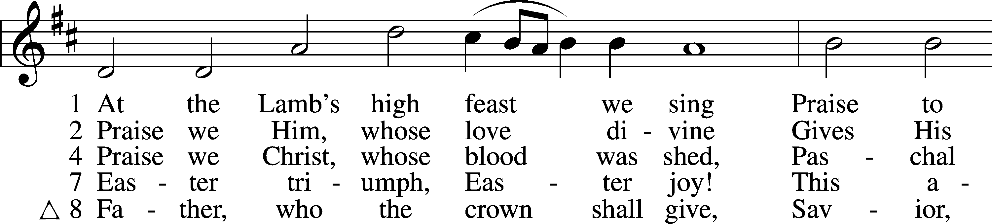
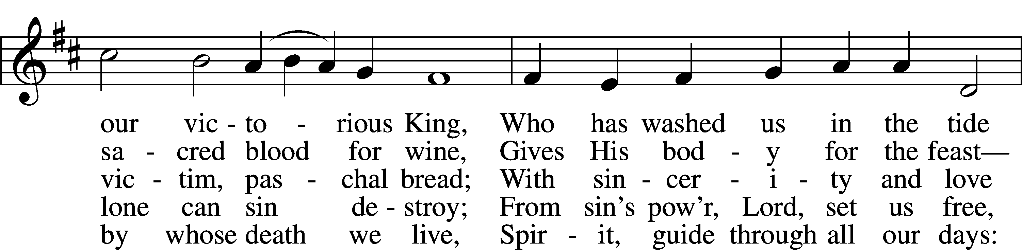
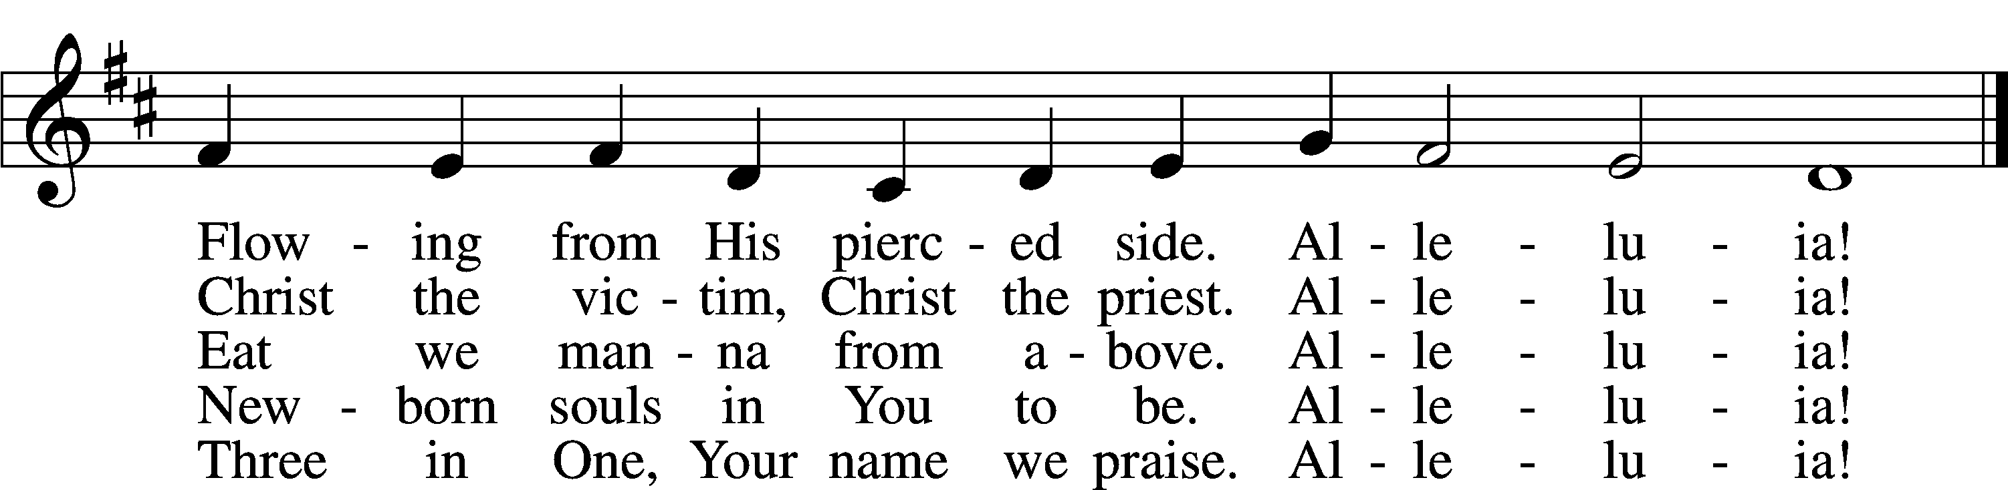
Tune and text: Public domain

The sign of the cross may be made by all in remembrance of their Baptism.

Invocation
P In the name of the Father and of the Son and of the Holy Spirit.
C Amen.

Exhortation LSB 184
P Beloved in the Lord! Let us draw near with a true heart and confess our sins unto God our Father, beseeching Him in the name of our Lord Jesus Christ to grant us forgiveness.

P Our help is in the name of the Lord,
C who made heaven and earth.

1
P I said, I will confess my transgressions unto the Lord,
C and You forgave the iniquity of my sin.

Silence for reflection on God’s Word and for self-examination.

Confession of Sins LSB 184
P O almighty God, merciful Father,
C I, a poor, miserable sinner, confess unto You all my sins and iniquities with which I have ever offended You and justly deserved Your temporal and eternal punishment. But I am heartily sorry for them and sincerely repent of them, and I pray You of Your boundless mercy and for the sake of the holy, innocent, bitter sufferings and death of Your beloved Son, Jesus Christ, to be gracious and merciful to me, a poor, sinful being.

Absolution LSB 185
P Upon this your confession, I, by virtue of my office, as a called and ordained servant of the Word, announce the grace of God unto all of you, and in the stead and by the command of my Lord Jesus Christ I forgive you all your sins in the name of the Father and of the T Son and of the Holy Spirit.
C Amen.

Gloria Patri LSB 186
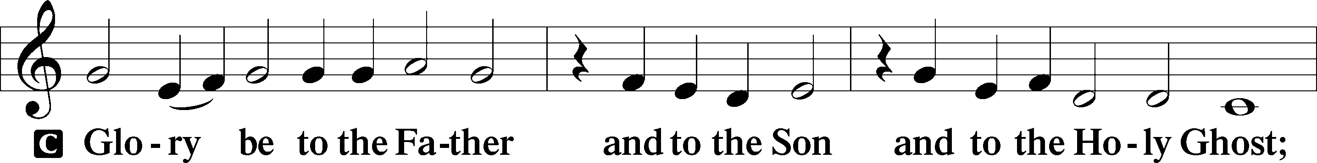
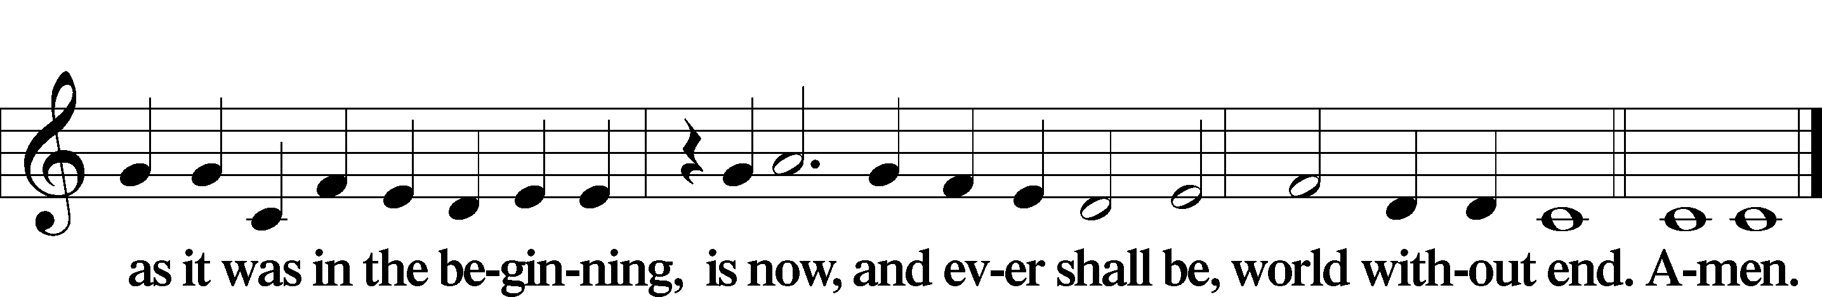

Kyrie LSB 186
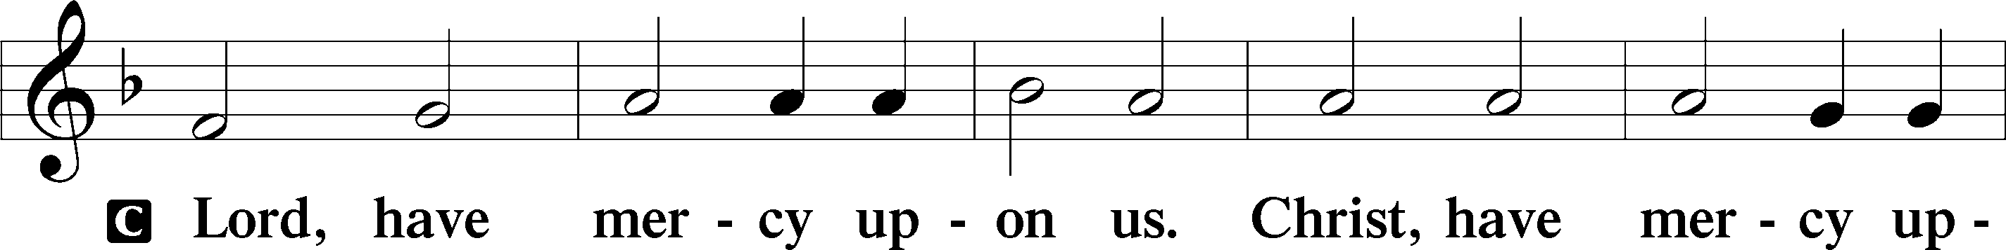
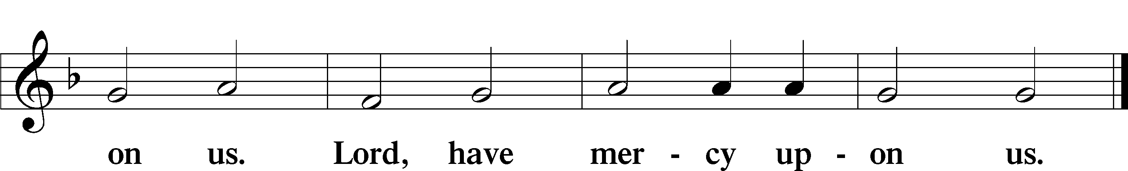
2
Gloria in Excelsis LSB 187
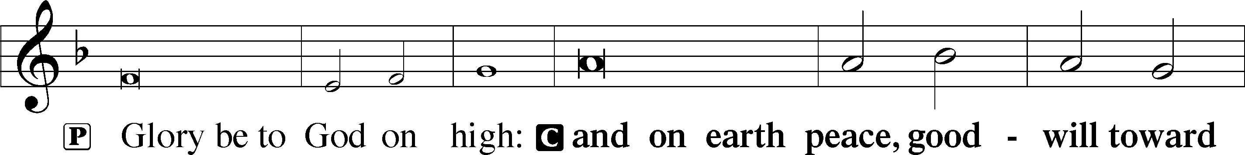
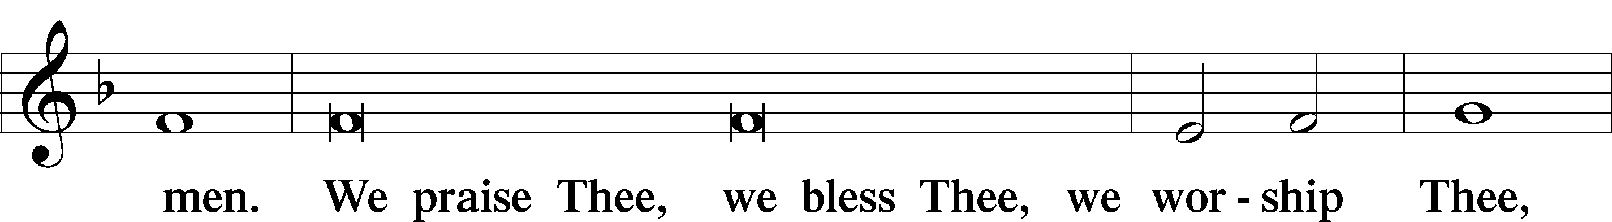
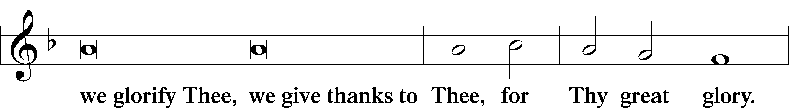
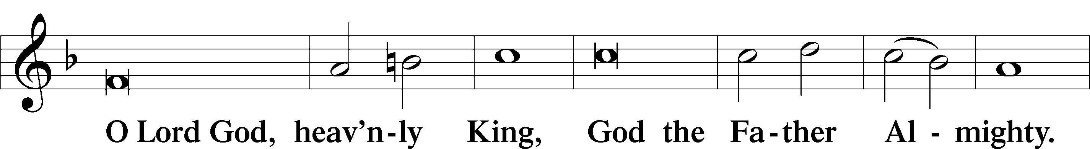
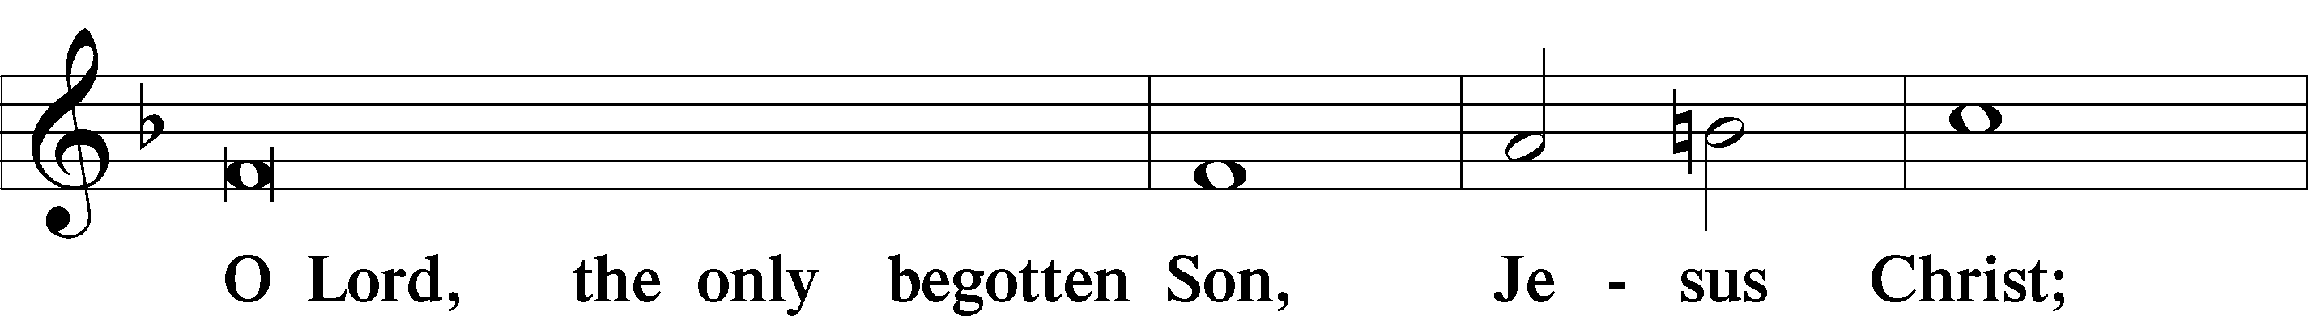
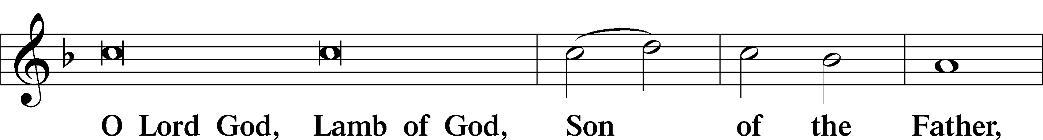
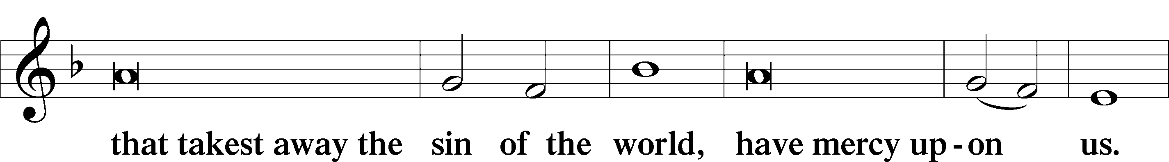
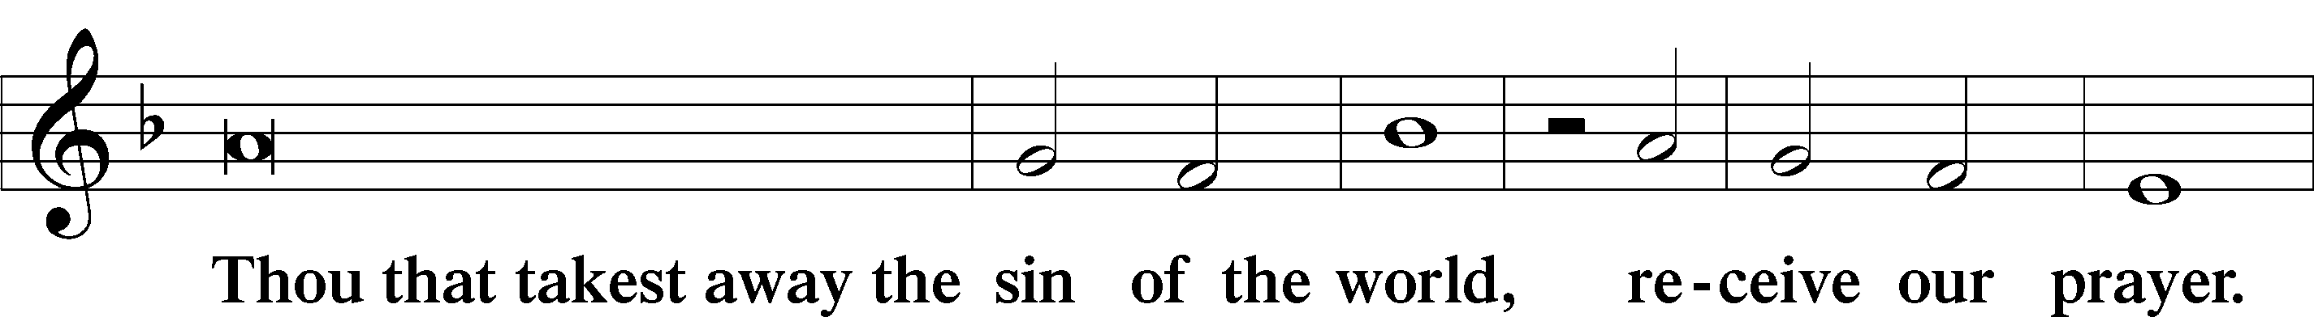
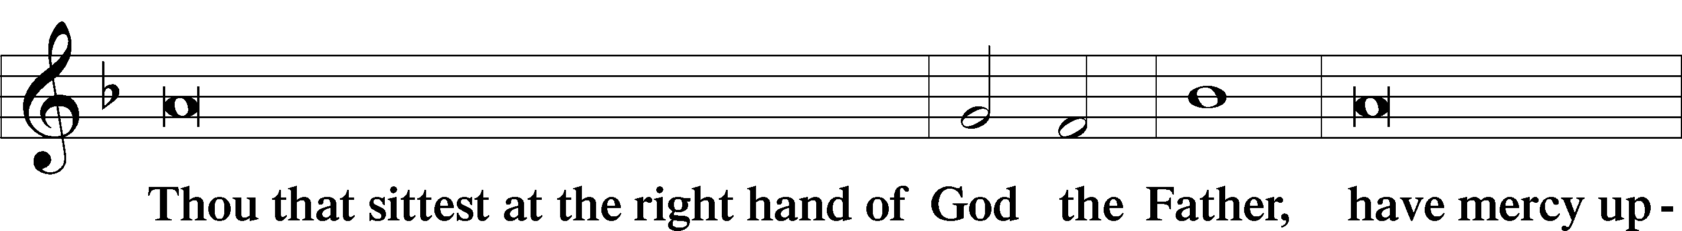
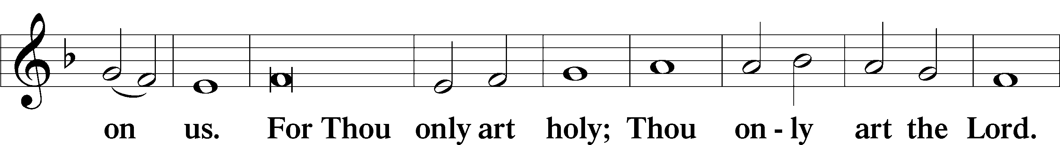
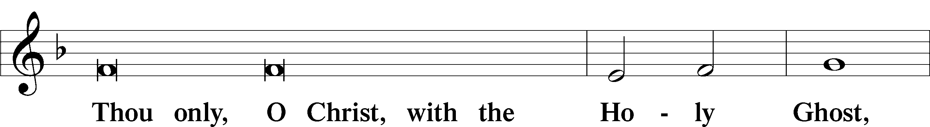

3
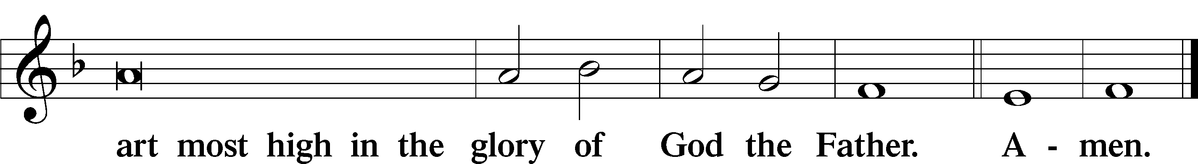

Salutation and Collect of the Day
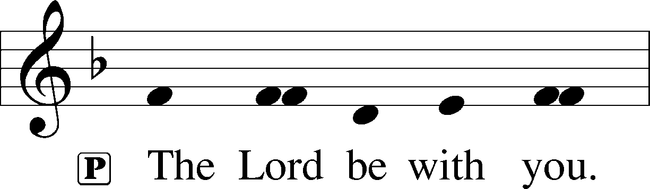
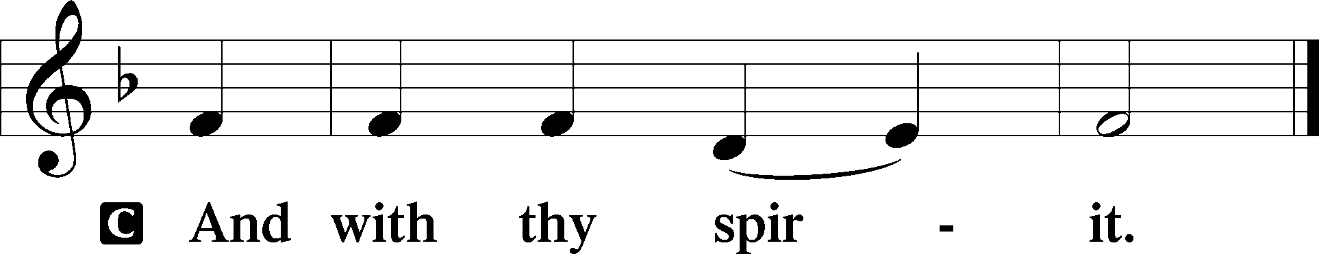

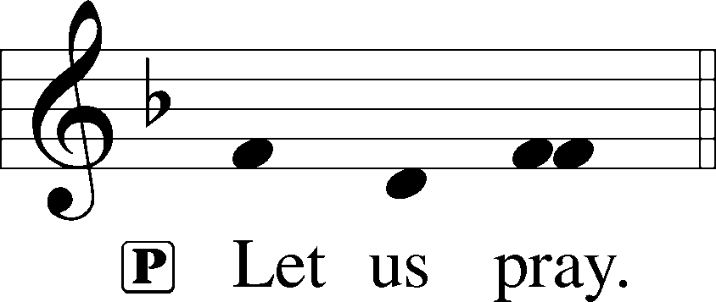

P O God, through the humiliation of Your Son You raised up the fallen world. Grant to Your faithful people, rescued from the peril of everlasting death, perpetual gladness and eternal joys; through Jesus Christ, our Lord, who lives and reigns with You and the Holy Spirit, one God, now and forever.

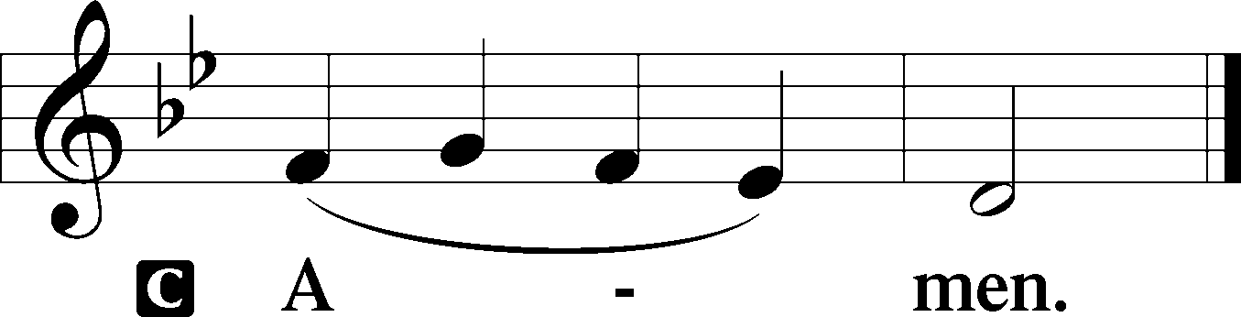

Sit

First Reading Acts 3:11–21
11While [the lame man who was now healed] clung to Peter and John, all the people ran together to them in the portico called Solomon’s, astounded. 12And when Peter saw it he addressed the people: “Men of Israel, why do you wonder at this, or why do you stare at us, as though by our own power or piety we have made him walk? 13The God of Abraham, the God of Isaac, and the God of Jacob, the God of our fathers, glorified his servant Jesus, whom you delivered over and denied in the presence of Pilate, when he had decided to release him.

4
14But you denied the Holy and Righteous One, and asked for a murderer to be granted to you, 15and you killed the Author of life, whom God raised from the dead. To this we are witnesses. 16And his name—by faith in his name—has made this man strong whom you see and know, and the faith that is through Jesus has given the man this perfect health in the presence of you all.
17“And now, brothers, I know that you acted in ignorance, as did also your rulers. 18But what God foretold by the mouth of all the prophets, that his Christ would suffer, he thus fulfilled. 19Repent therefore, and turn again, that your sins may be blotted out, 20that times of refreshing may come from the presence of the Lord, and that he may send the Christ appointed for you, Jesus, 21whom heaven must receive until the time for restoring all the things about which God spoke by the mouth of his holy prophets long ago.”

A This is the Word of the Lord.
C Thanks be to God.

Anthem – “God Loves Me Dearly” Chancel Choir

Epistle 1 John 3:1–7
1See what kind of love the Father has given to us, that we should be called children of God; and so we are. The reason why the world does not know us is that it did not know him. 2Beloved, we are God’s children now, and what we will be has not yet appeared; but we know that when he appears we shall be like him, because we shall see him as he is. 3And everyone who thus hopes in him purifies himself as he is pure.
4Everyone who makes a practice of sinning also practices lawlessness; sin is lawlessness. 5You know that he appeared to take away sins, and in him there is no sin. 6No one who abides in him keeps on sinning; no one who keeps on sinning has either seen him or known him. 7Little children, let no one deceive you. Whoever practices righteousness is righteous, as he is righteous.

A This is the Word of the Lord.
C Thanks be to God.

Stand

5
Alleluia LSB 190
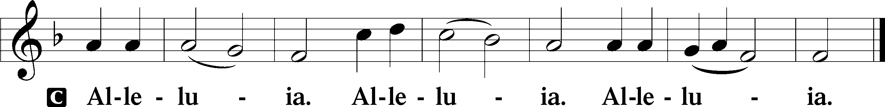

Holy Gospel Luke 24:36–49
P The Holy Gospel according to St. Luke, the twenty-fourth chapter.

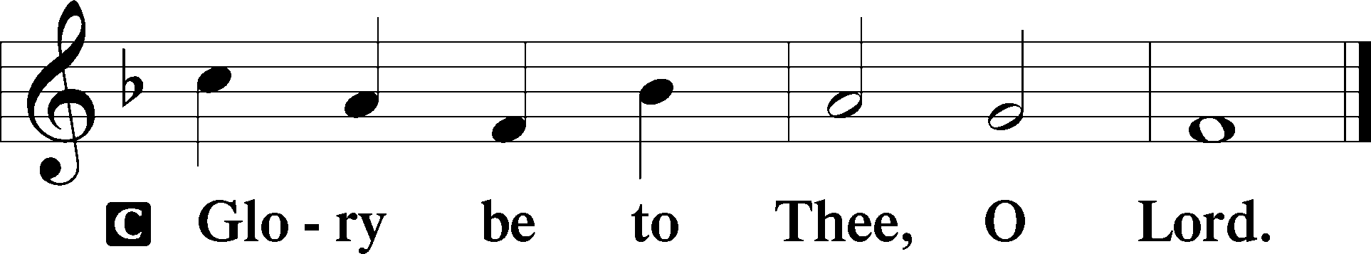

36As they were talking about these things, Jesus himself stood among them, and said to them, “Peace to you!” 37But they were startled and frightened and thought they saw a spirit. 38And he said to them, “Why are you troubled, and why do doubts arise in your hearts? 39See my hands and my feet, that it is I myself. Touch me, and see. For a spirit does not have flesh and bones as you see that I have.” 40And when he had said this, he showed them his hands and his feet. 41And while they still disbelieved for joy and were marveling, he said to them, “Have you anything here to eat?” 42They gave him a piece of broiled fish, 43and he took it and ate before them.
44Then he said to them, “These are my words that I spoke to you while I was still with you, that everything written about me in the Law of Moses and the Prophets and the Psalms must be fulfilled.” 45Then he opened their minds to understand the Scriptures, 46and said to them, “Thus it is written, that the Christ should suffer and on the third day rise from the dead, 47and that repentance and forgiveness of sins should be proclaimed in his name to all nations, beginning from Jerusalem. 48You are witnesses of these things. 49And behold, I am sending the promise of my Father upon you. But stay in the city until you are clothed with power from on high.”

P This is the Gospel of the Lord.

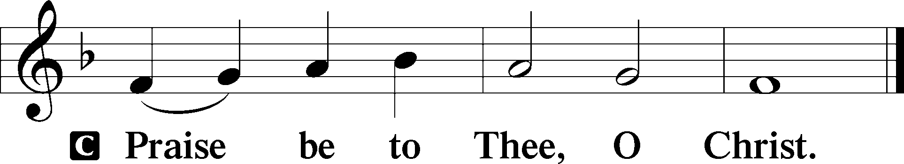

6
Nicene Creed
C I believe in one God,
the Father Almighty,
maker of heaven and earth
and of all things visible and invisible.

And in one Lord Jesus Christ,
the only-begotten Son of God,
begotten of His Father before all worlds,
God of God, Light of Light,
very God of very God,
begotten, not made,
being of one substance with the Father,
by whom all things were made;
who for us men and for our salvation came down from heaven
and was incarnate by the Holy Spirit of the virgin Mary
and was made man;
and was crucified also for us under Pontius Pilate.
He suffered and was buried.
And the third day He rose again according to the Scriptures
and ascended into heaven
and sits at the right hand of the Father.
And He will come again with glory to judge both the living and the dead,
whose kingdom will have no end.

And I believe in the Holy Spirit,
the Lord and giver of life,
who proceeds from the Father and the Son,
who with the Father and the Son together is worshiped and glorified,
who spoke by the prophets.
And I believe in one holy Christian and apostolic Church,
I acknowledge one Baptism for the remission of sins,
and I look for the resurrection of the dead
and the life T of the world to come. Amen.

Sit

7
Sermon Hymn 830 Spread the Reign of God the Lord
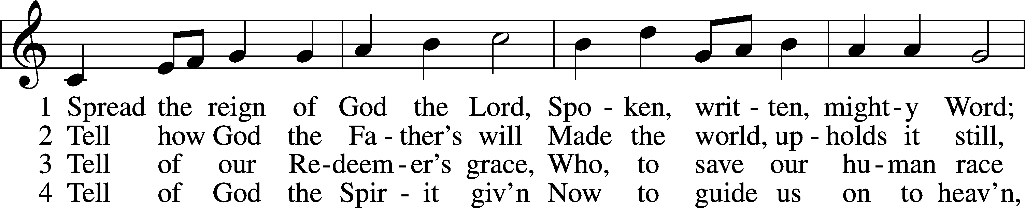
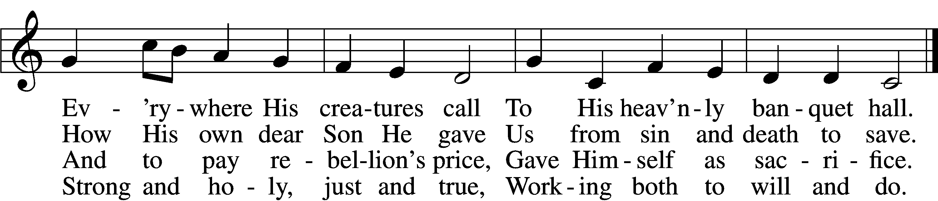

5 Enter, mighty Word, the field;
Ripe the promise of its yield.
But the reapers, oh, how few
For the work there is to do!

6 Lord of harvest, great and kind,
Rouse to action heart and mind;
Let the gath’ring nations all
See Your light and heed Your call.
Text and tune: Public domain

Sermon “Now and Not Yet” 1 John 3

P The peace of God, which passes all understanding, keep your hearts and minds in Christ Jesus.
C Amen.

Offertory LSB 192
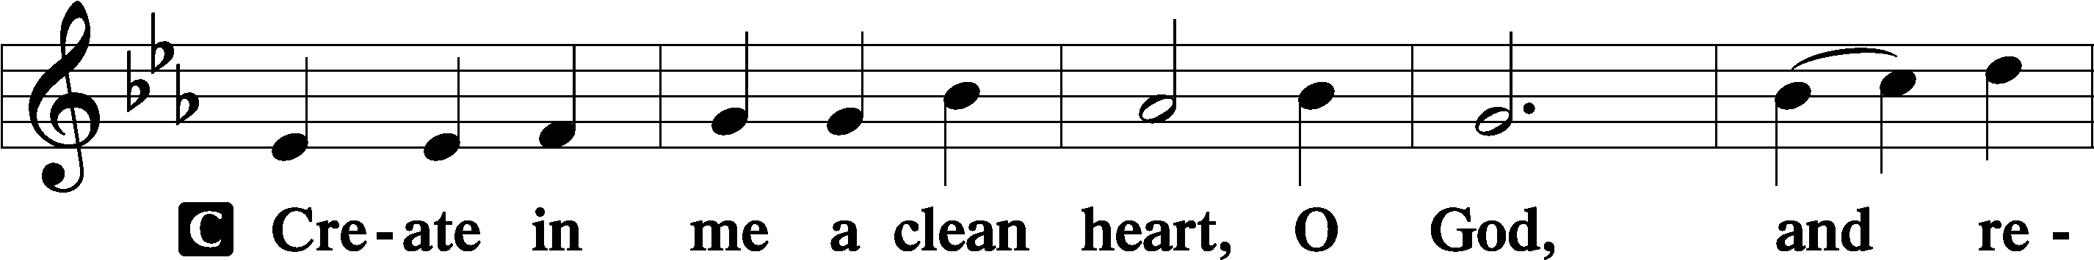
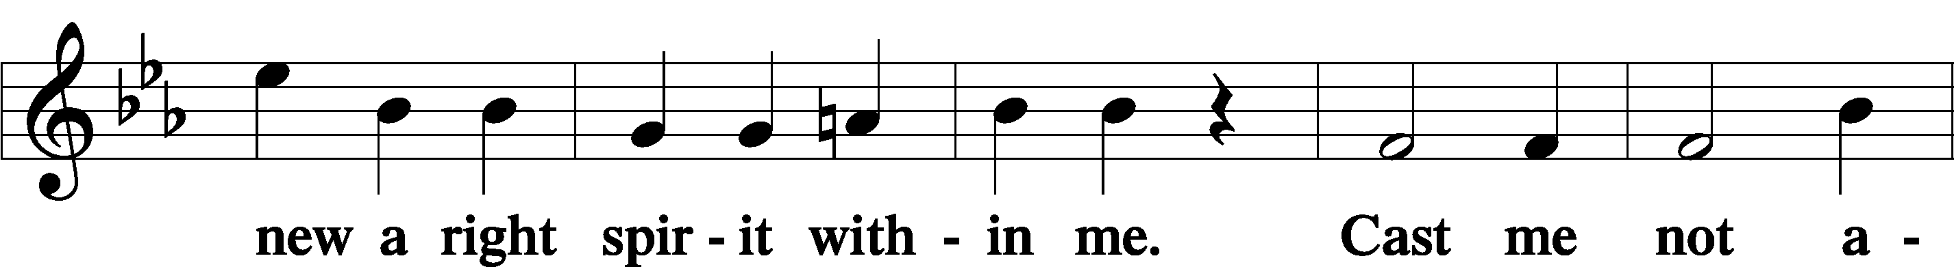
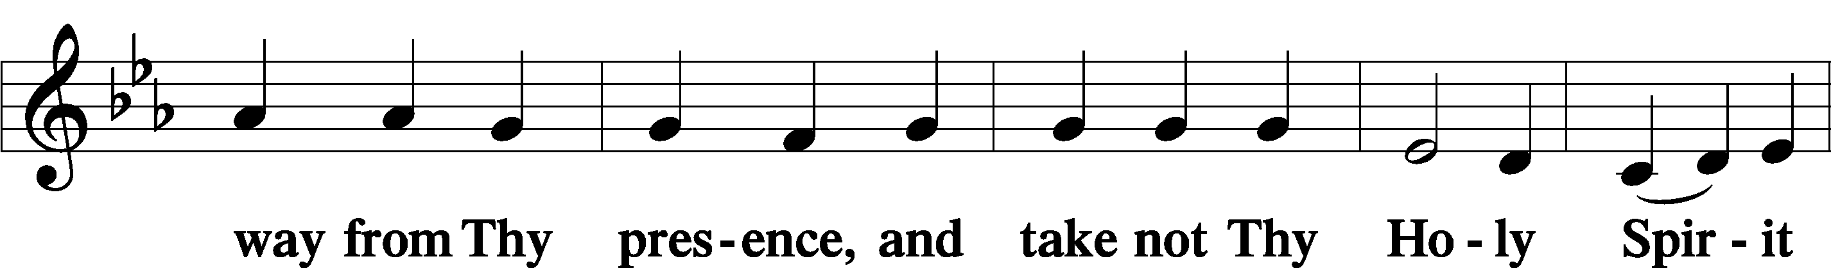

8
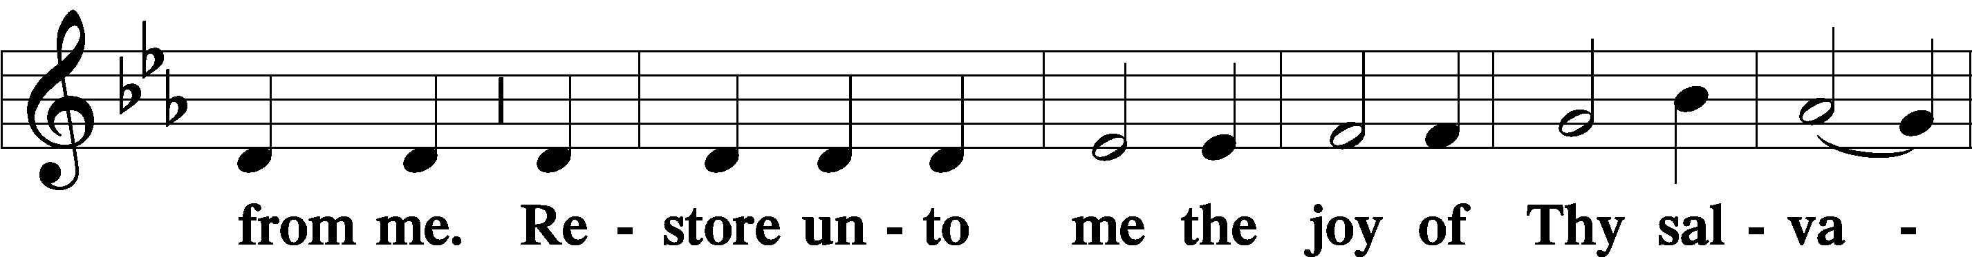
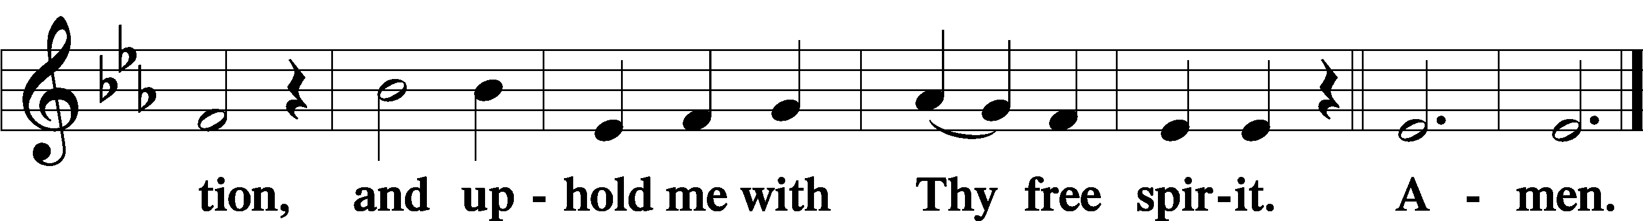

Sit

Offering

Stand

Prayer of the Church

Preface LSB 194
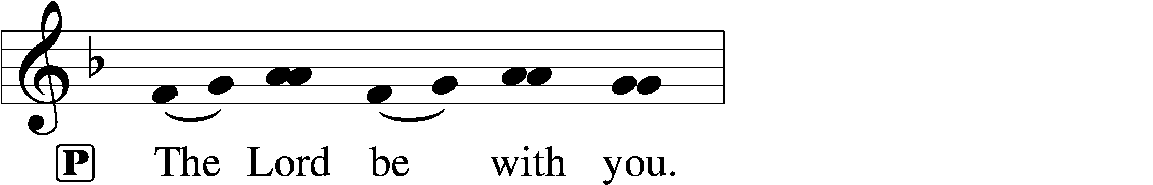
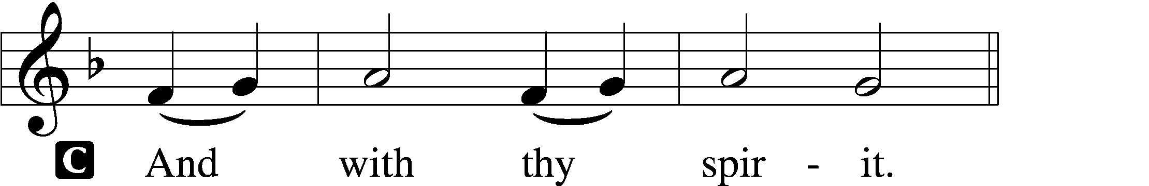

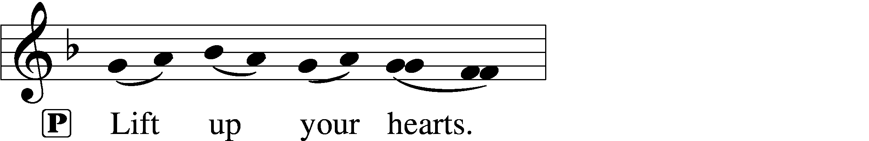
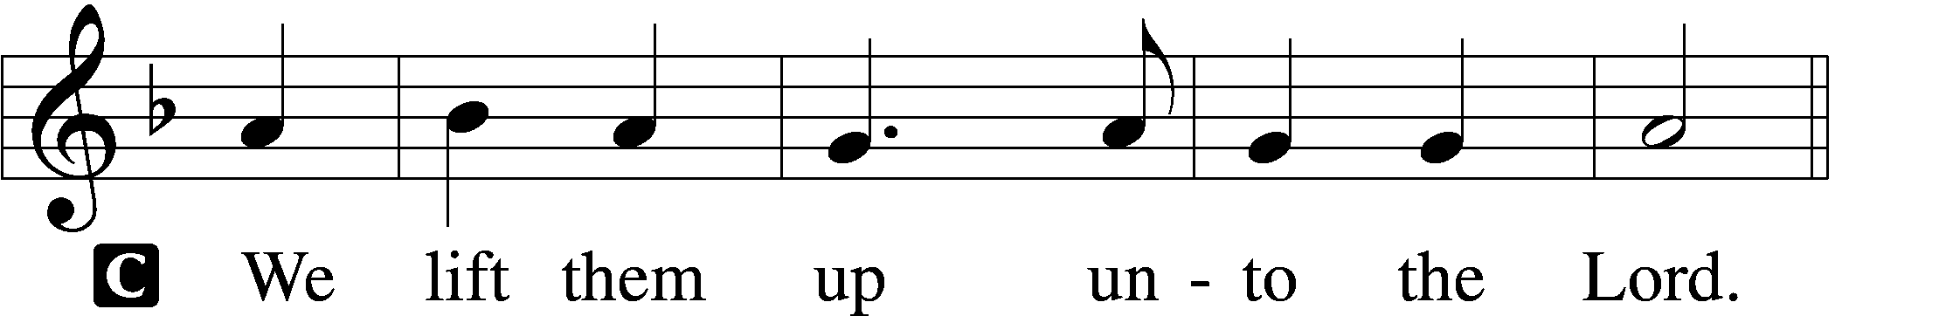

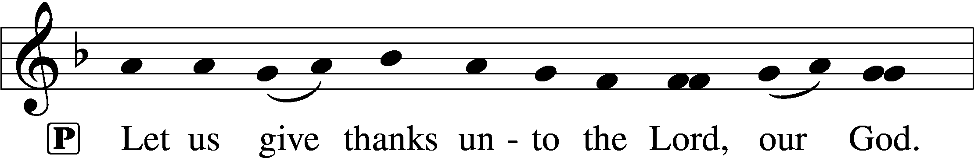
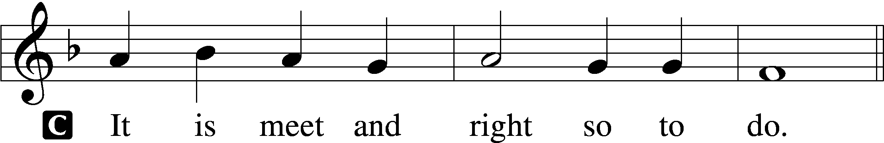

9
Proper Preface (Full)
P It is truly meet, right, and salutary that we should at all times and in all places give thanks to You, holy Lord, almighty Father, everlasting God. And most especially are we bound to praise You on this day for the glorious resurrection of Your Son, Jesus Christ, the very Paschal Lamb, who was sacrificed for us and bore the sins of the world. By His dying He has destroyed death, and by His rising again He has restored to us everlasting life. Therefore with Mary Magdalene, Peter and John, and with all the witnesses of the resurrection, with angels and archangels, and with all the company of heaven we laud and magnify Your glorious name, evermore praising You and saying:

Sanctus LSB 195
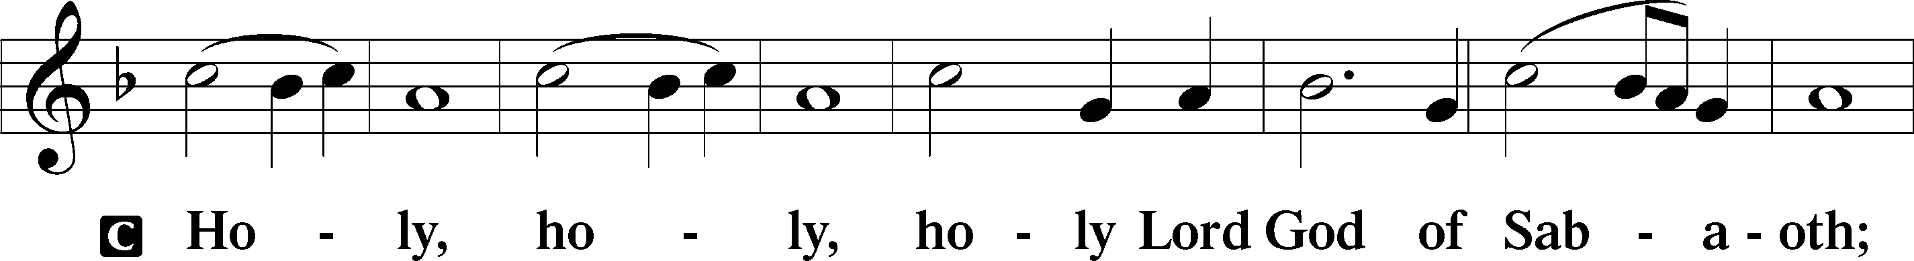
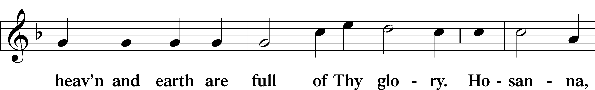
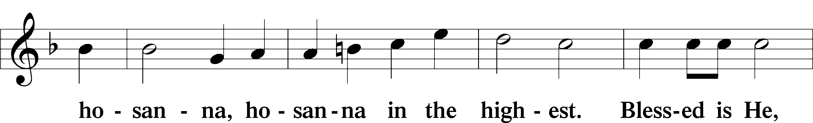
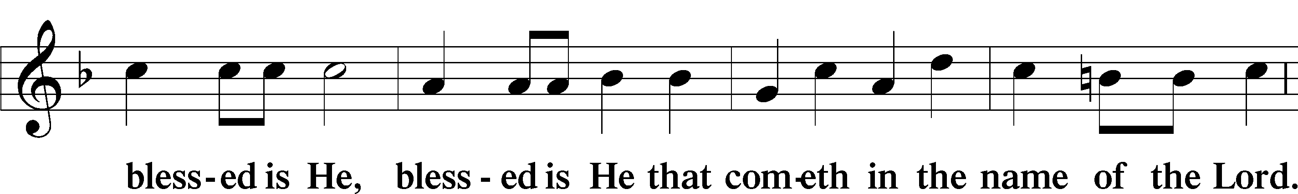
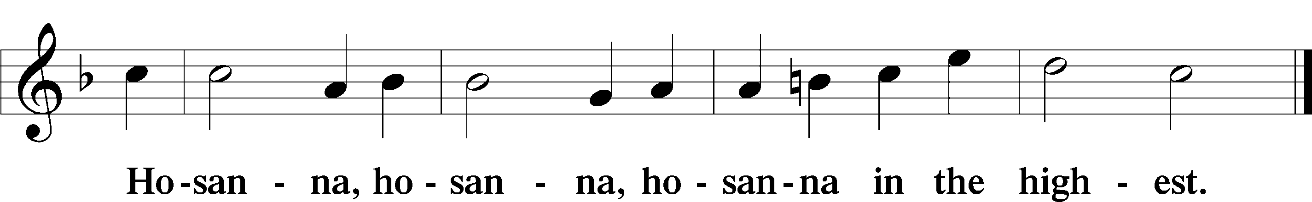

Lord’s Prayer 196
Our Father who art in heaven, hallowed be Thy name, Thy kingdom come, Thy will be done on earth as it is in heaven;
give us this day our daily bread; and forgive us our trespasses as we forgive those who trespass against us; and lead us not into temptation, but deliver us from evil.
For Thine is the kingdom and the power and the glory forever and ever. Amen.
10
The Words of Our Lord LSB 197
P Our Lord Jesus Christ, on the night when He was betrayed, took bread, and when He had given thanks, He broke it and gave it to the disciples and said: “Take, eat; this is My T body, which is given for you. This do in remembrance of Me.”
In the same way also He took the cup after supper, and when He had given thanks, He gave it to them, saying: “Drink of it, all of you; this cup is the new testament in My T blood, which is shed for you for the forgiveness of sins. This do, as often as you drink it, in remembrance of Me.”

Pax Domini LSB 197
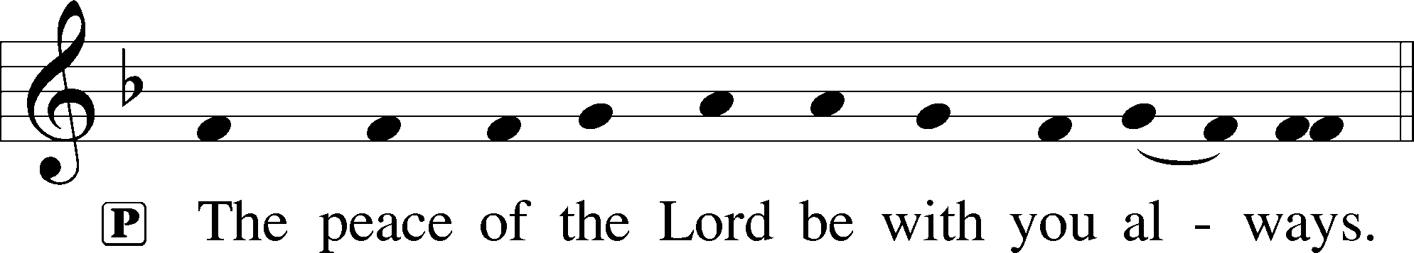

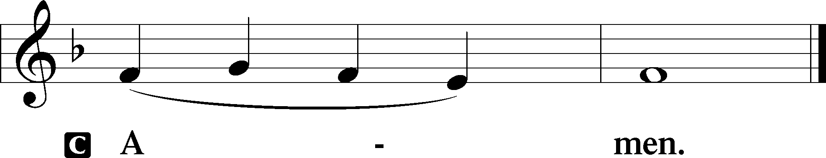

Agnus Dei LSB 198
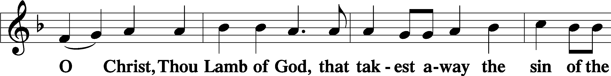
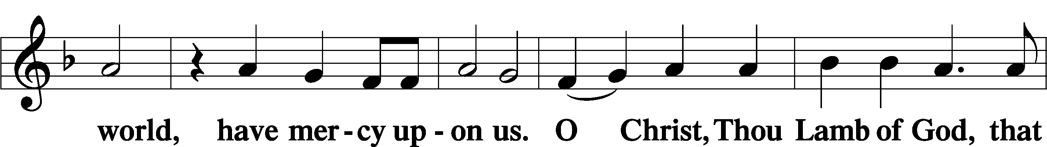
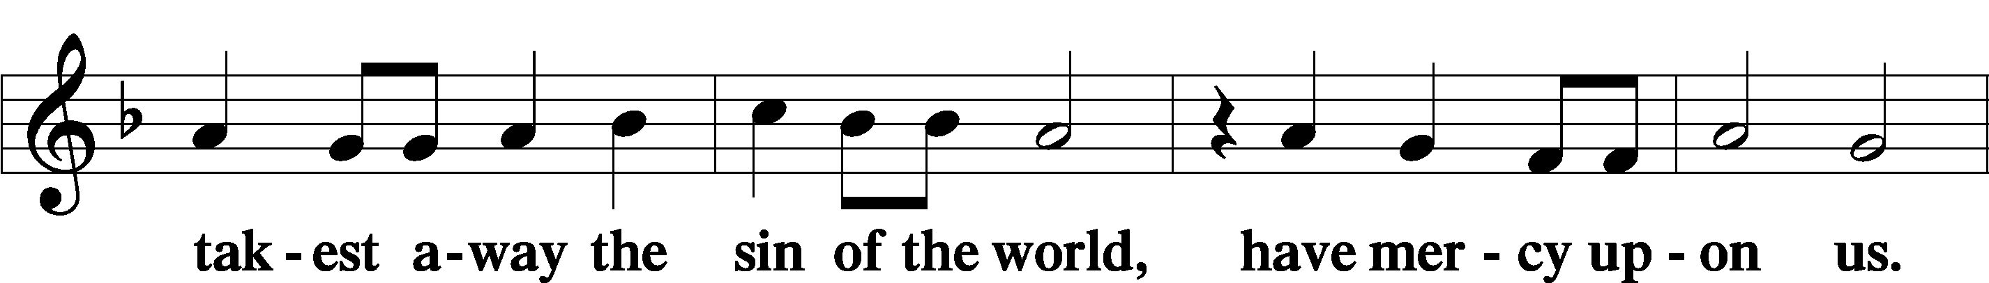
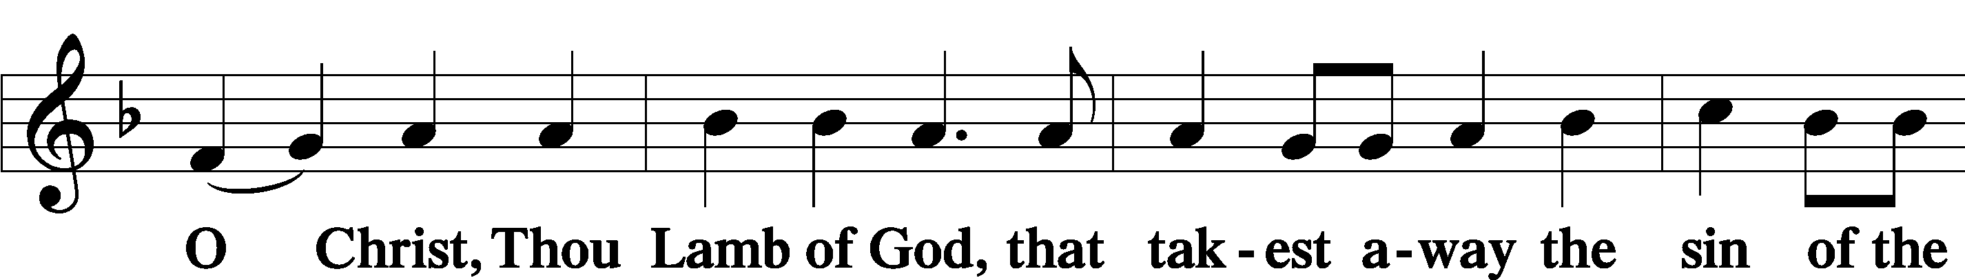
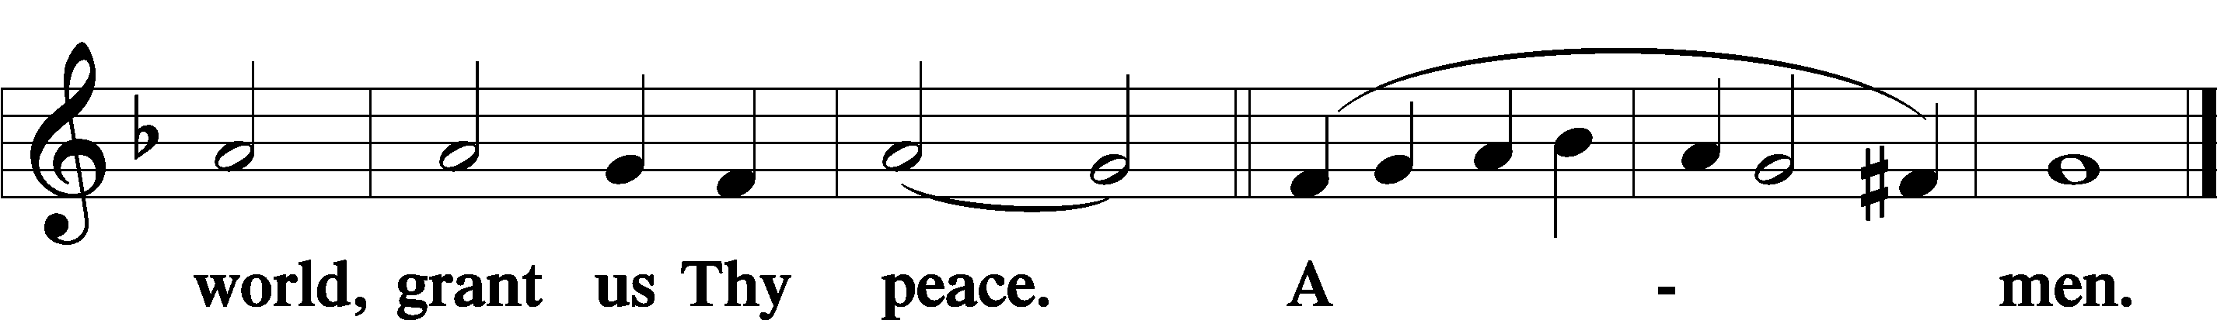

Sit
11
Distribution/Hymns

725 Children of the Heavenly Father
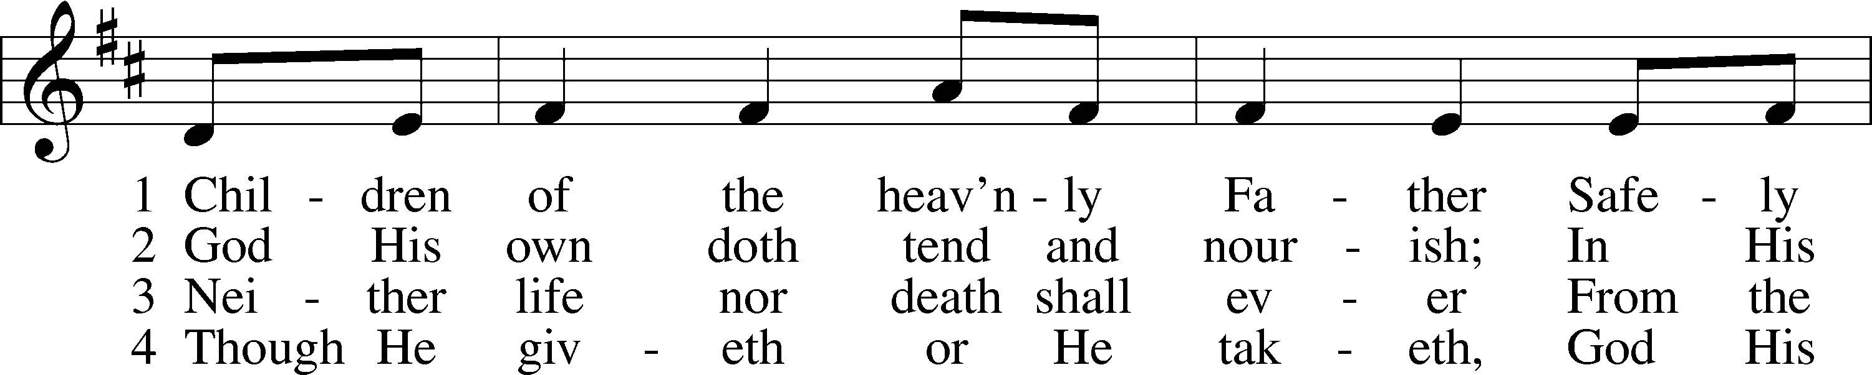
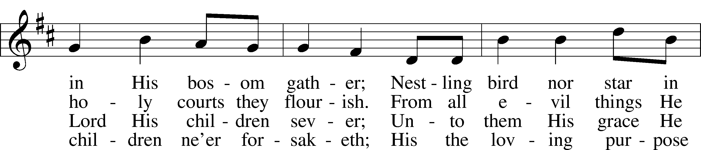
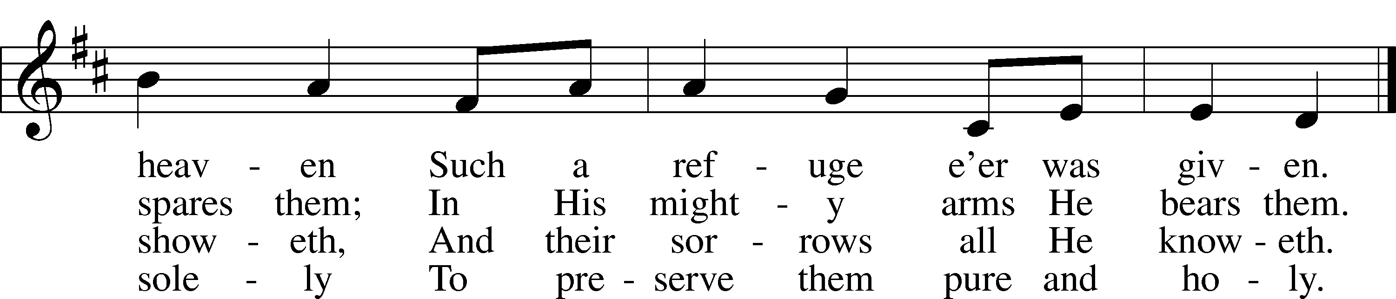
Text: © Augsburg Publishing House. Used by permission: LSB Hymn License no. 110000888
Tune: Public domain

12
700 Love Divine, All Loves Excelling
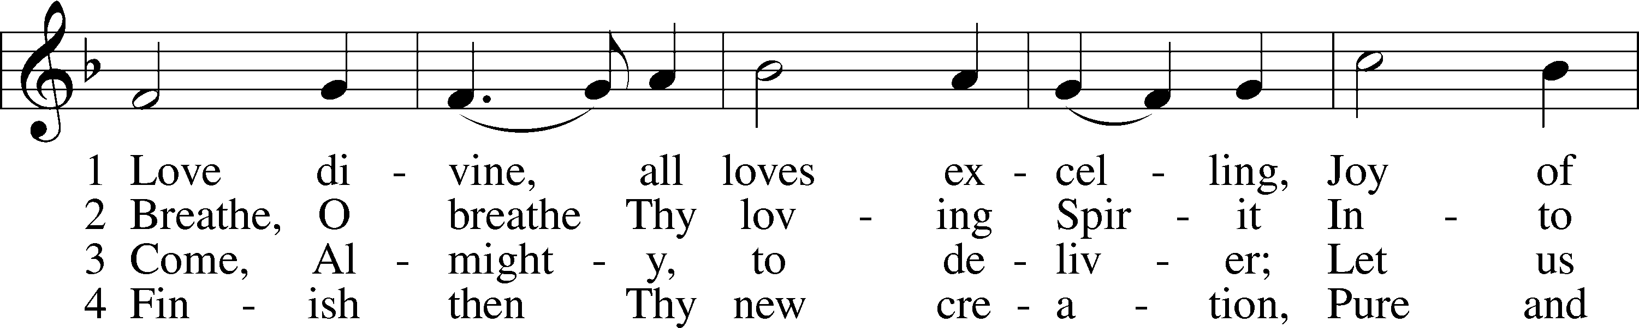
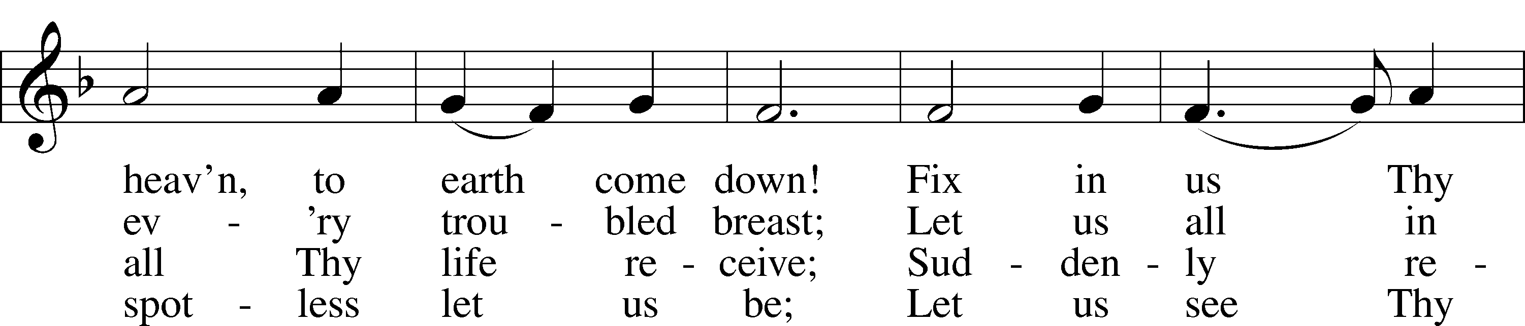
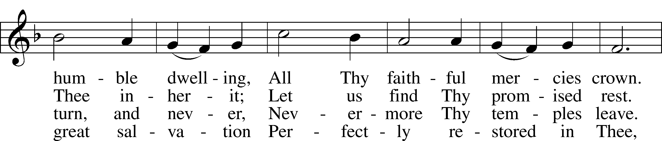
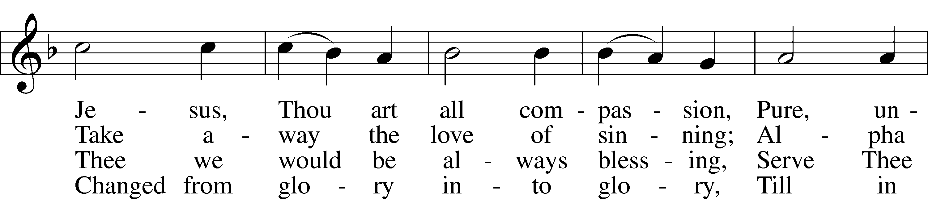
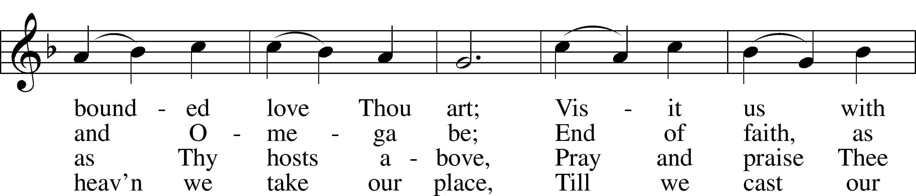
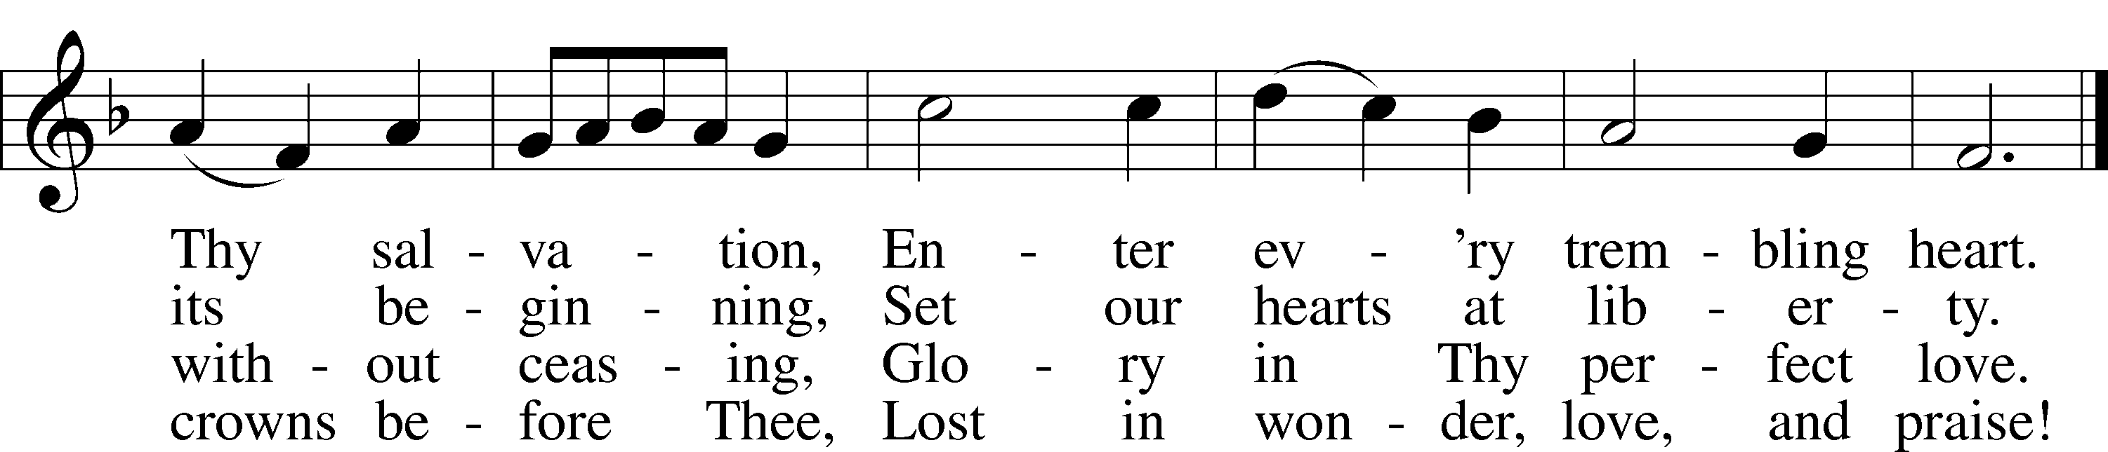
Tune and text: Public domain

13
619 Thy Body, Given for Me, O Savior
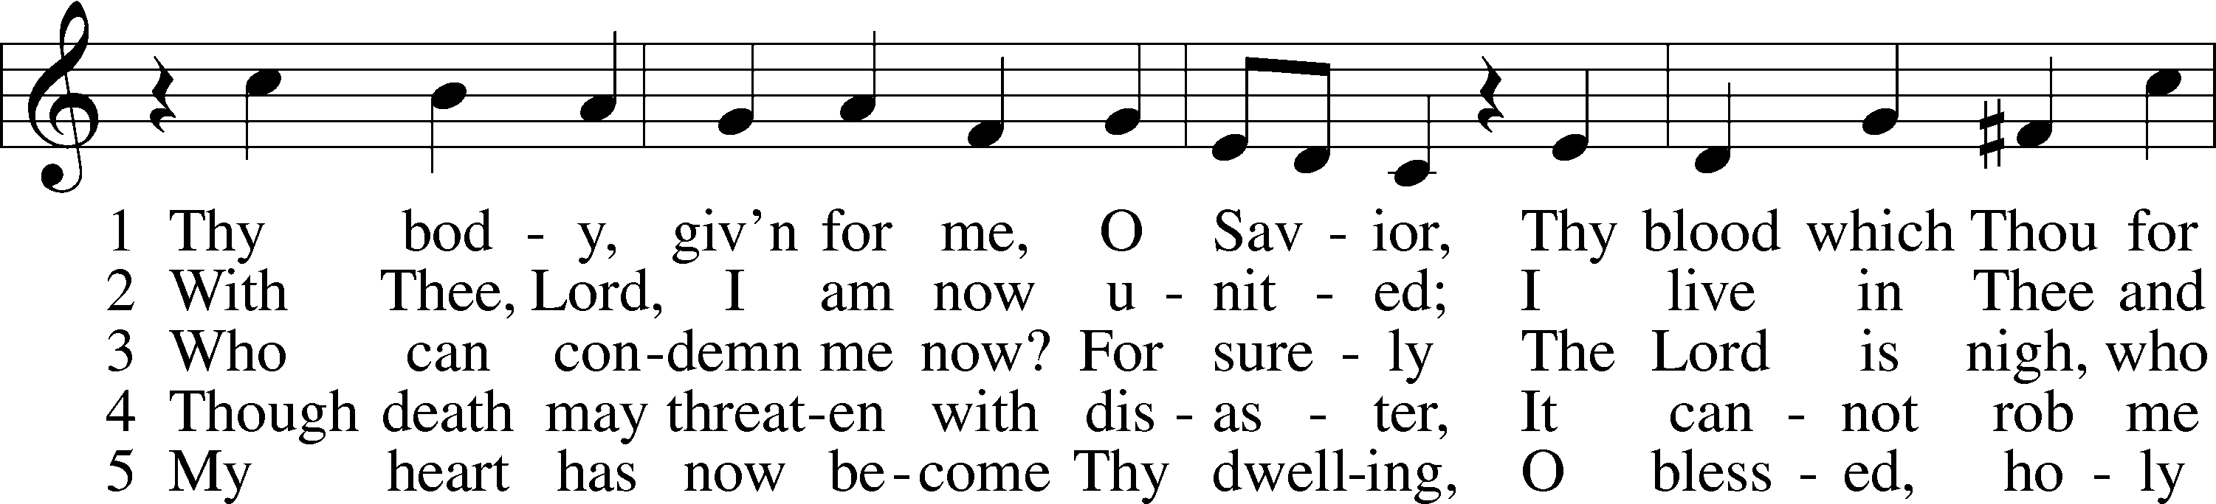
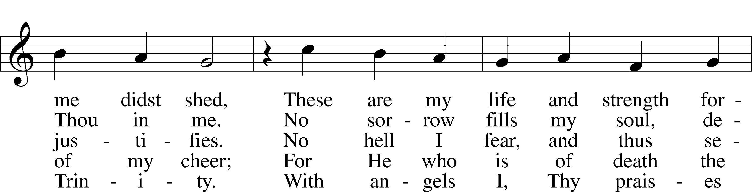
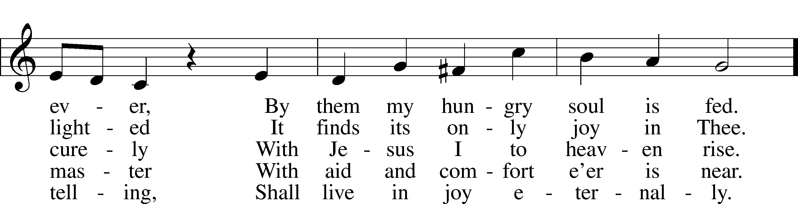
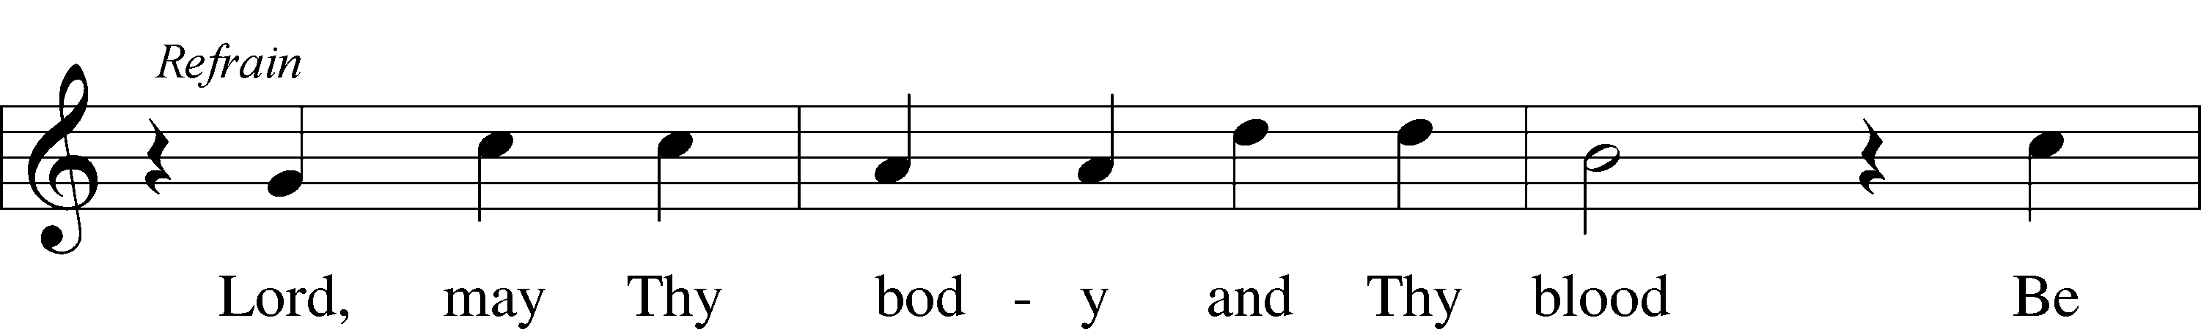
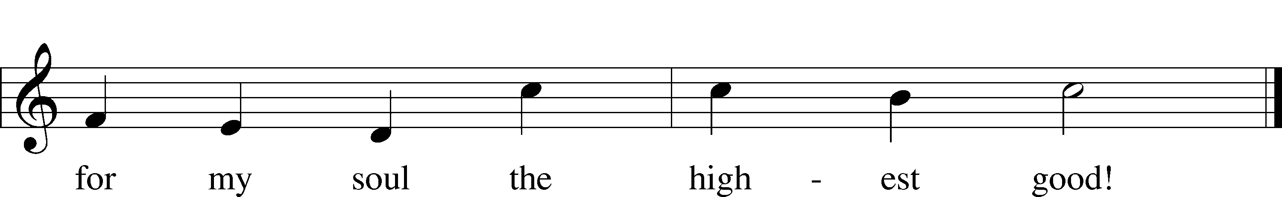
Tune: Public domain
Text: © 1941 Concordia Publishing House. Used by permission: LSB Hymn License no. 110000888

Stand

14
Nunc Dimittis LSB 199
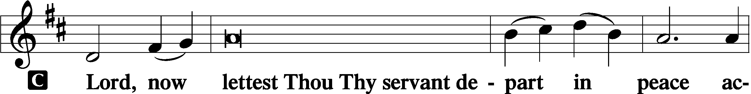

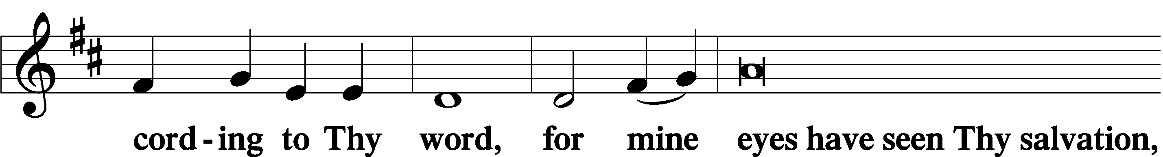

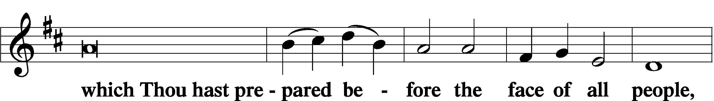

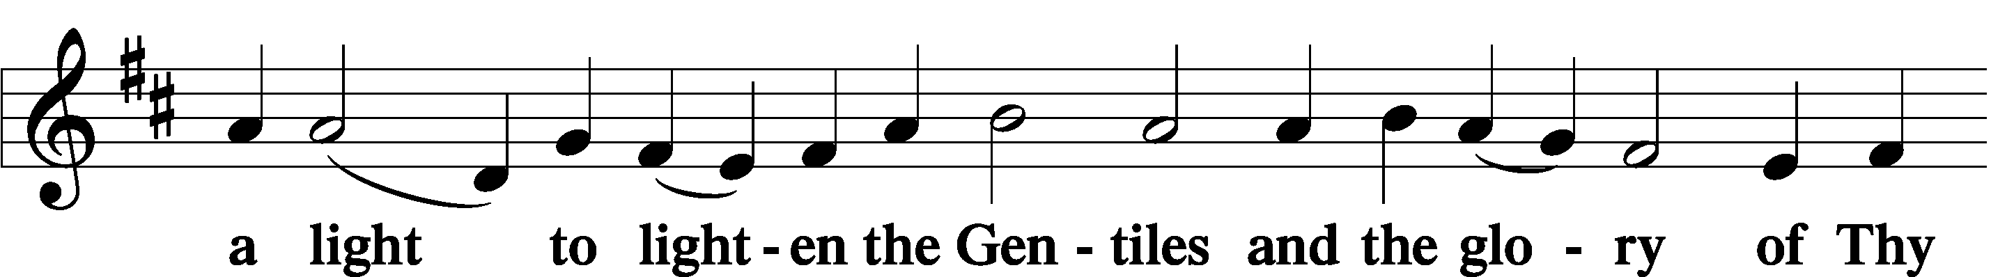

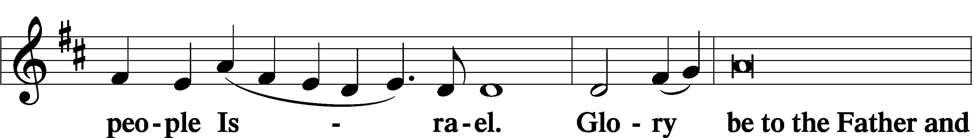

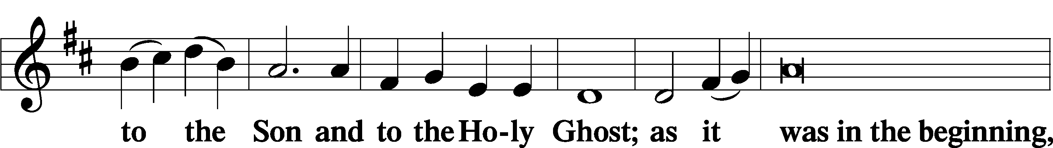

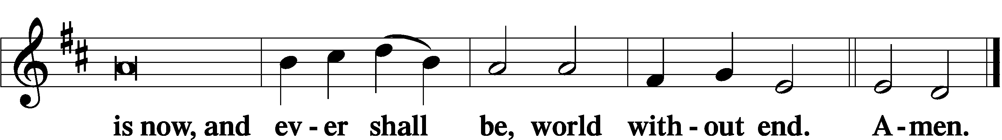

Thanksgiving LSB 200
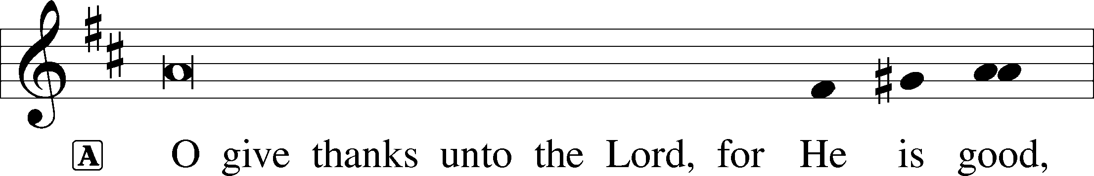

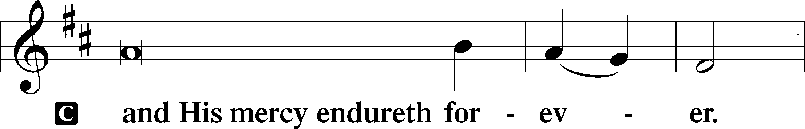
15
Post-Communion Collect
A Let us pray.
We give thanks to You, almighty God, that You have refreshed us through this salutary gift, and we implore You that of Your mercy You would strengthen us through the same in faith toward You and in fervent love toward one another; through Jesus Christ, Your Son, our Lord, who lives and reigns with You and the Holy Spirit, one God, now and forever.

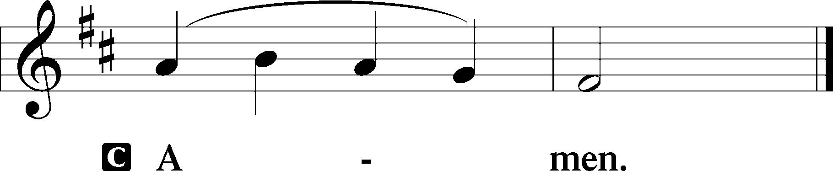

Salutation LSB 201
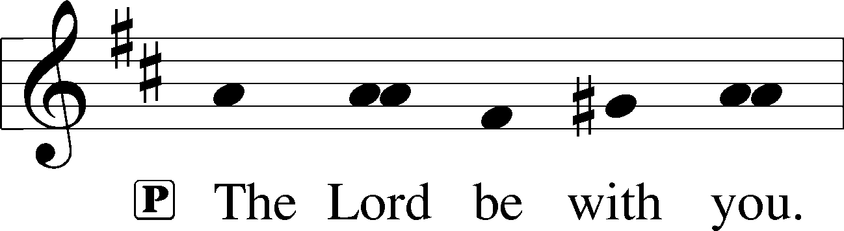

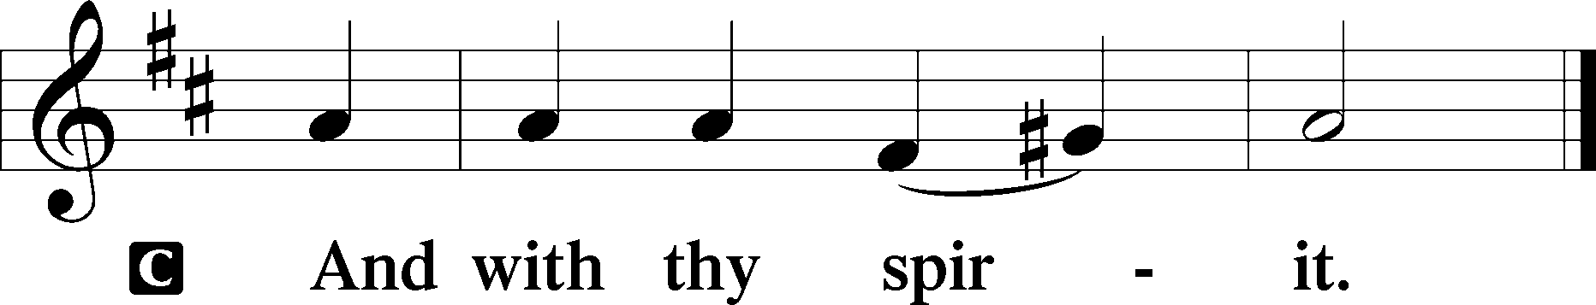

Benedicamus LSB 202
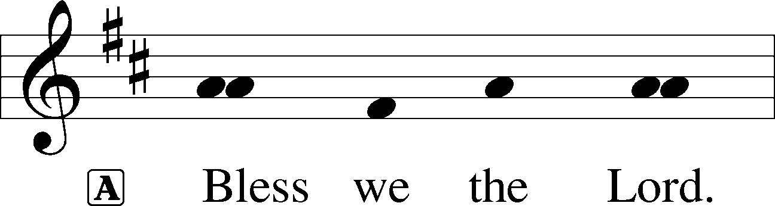

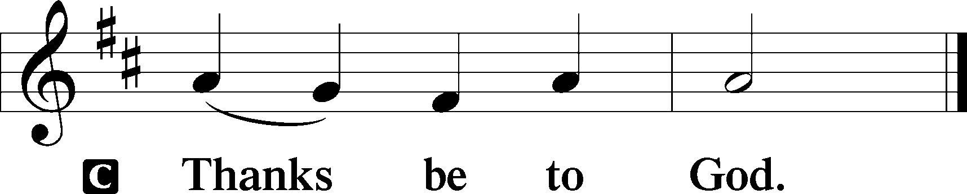

Benediction LSB 202
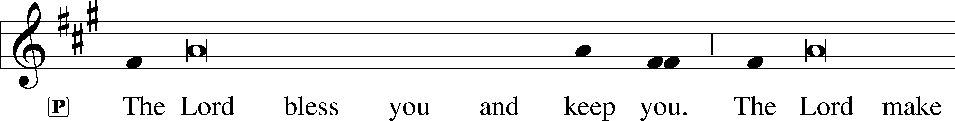
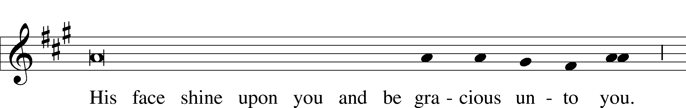

16
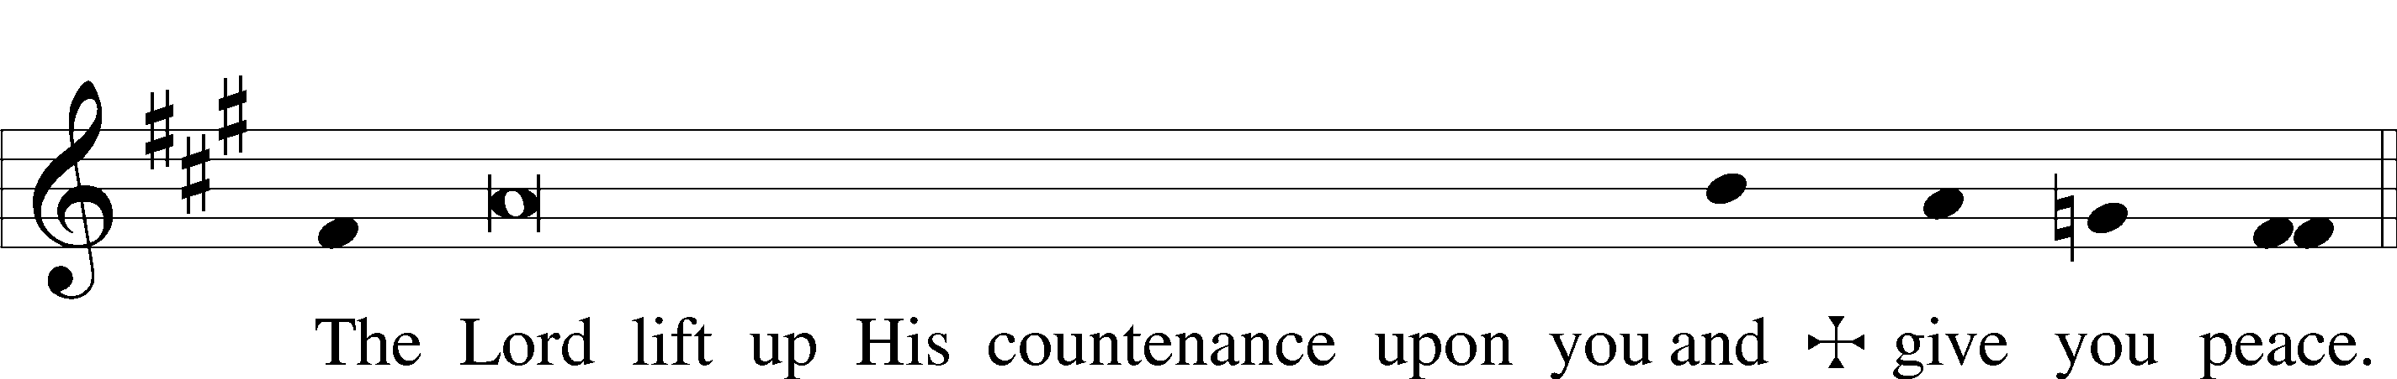

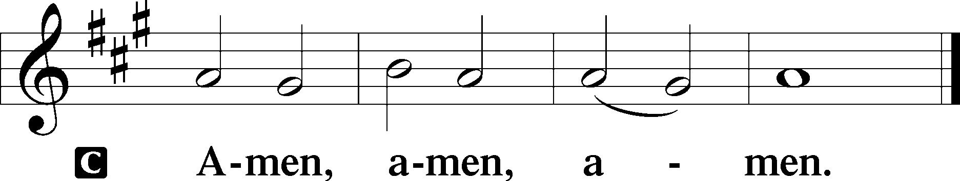

Closing Hymn 488 He Is Arisen! Glorious Word
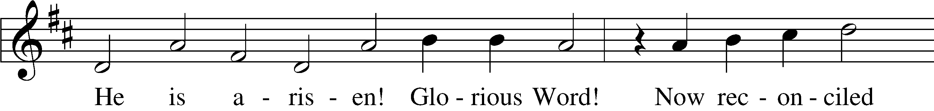
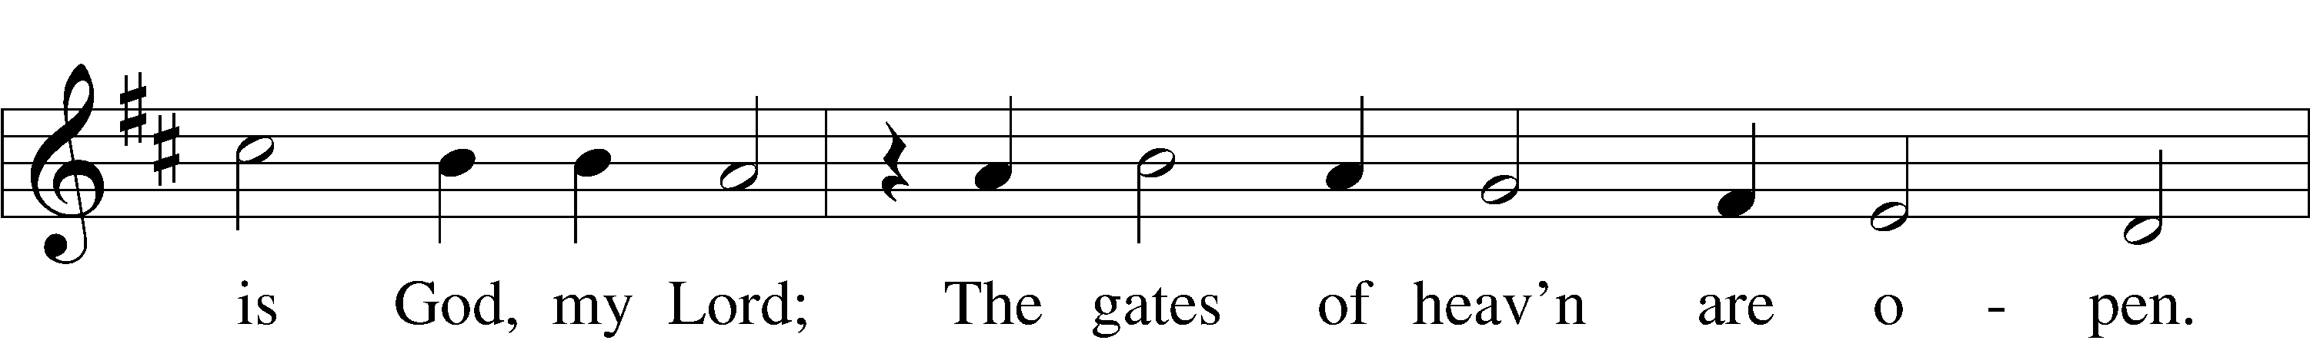
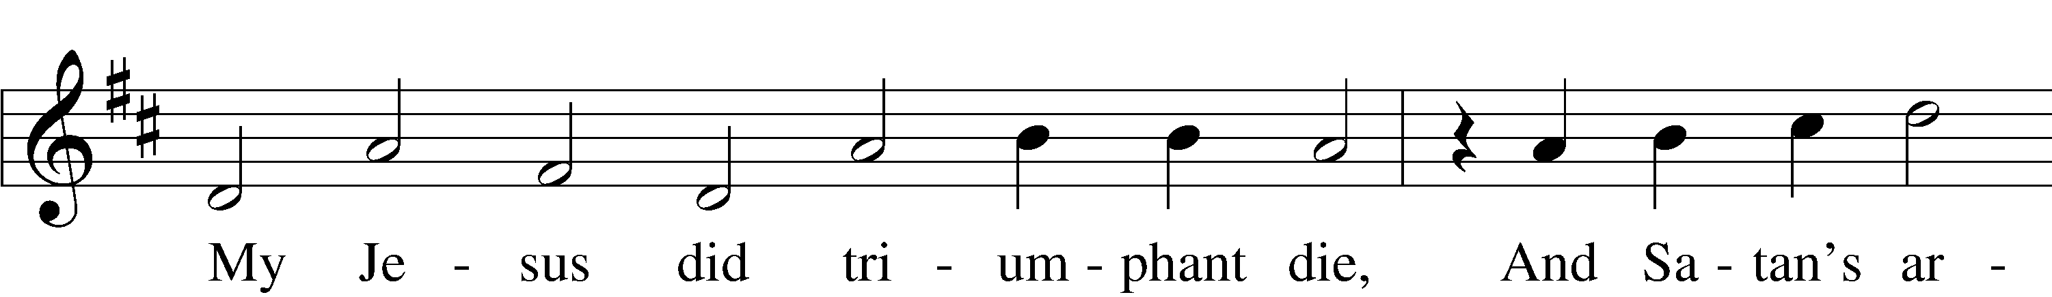
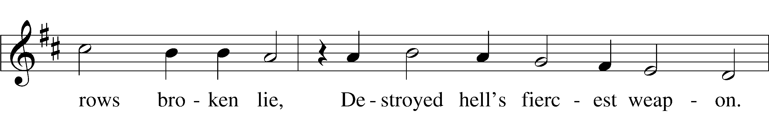
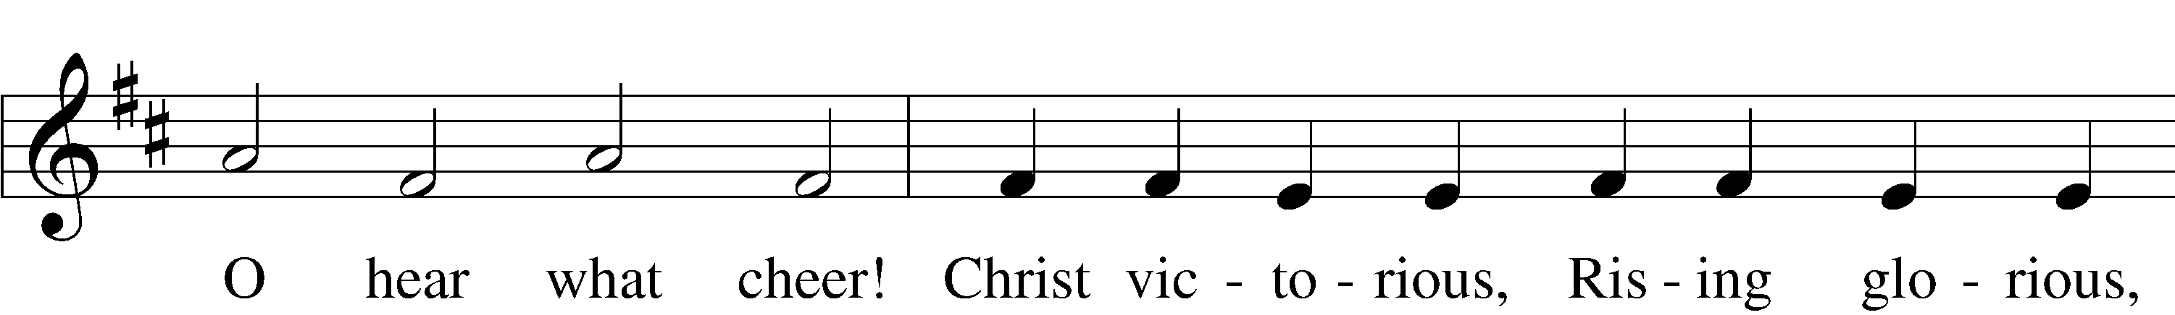
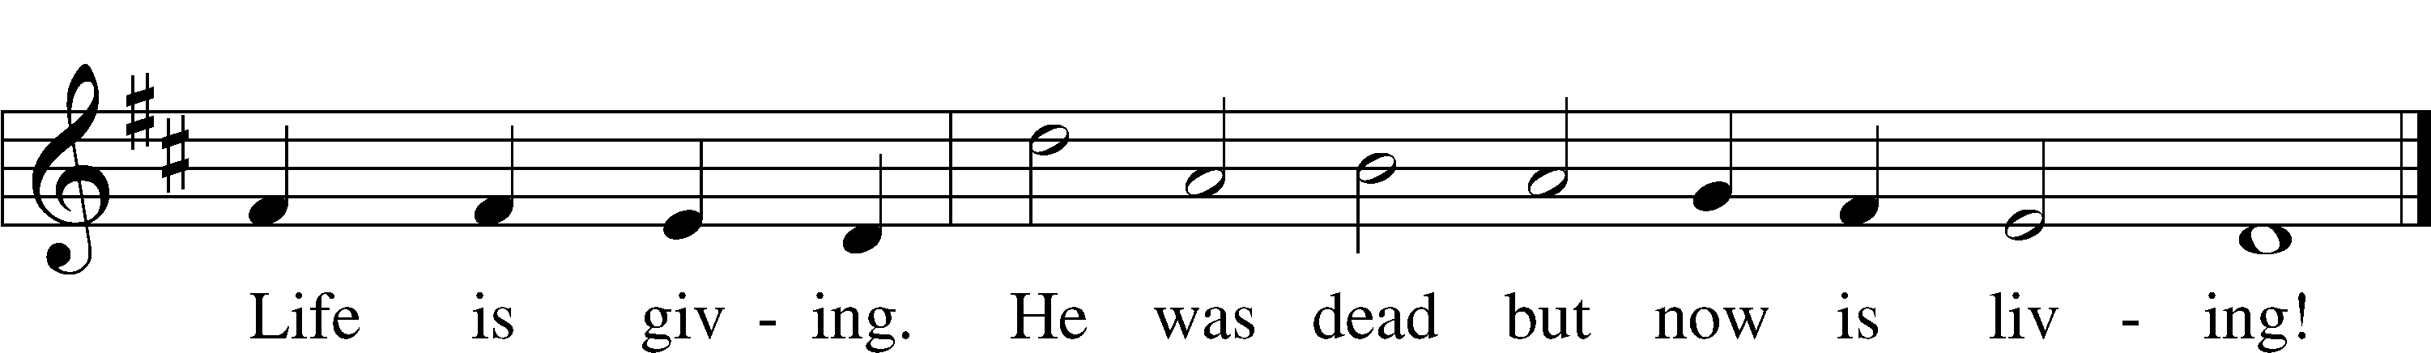
Text and tune: Public domain

Silent Prayer

Announcements

Postlude
17

Acknowledgments
Unless otherwise indicated, Scripture quotations are from the ESV® Bible (The Holy Bible, English Standard Version®), copyright © 2001 by Crossway, a publishing ministry of Good News Publishers. Used by permission. All rights reserved.
Created by Lutheran Service Builder © 2021 Concordia Publishing House.
18

