Matins
September 27, 2020
Opening Hymn 940 Holy God, We Praise Thy Name
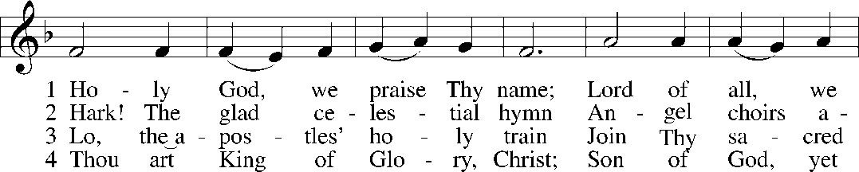
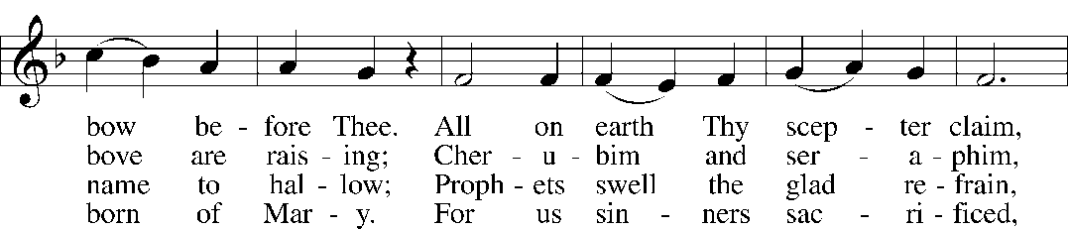
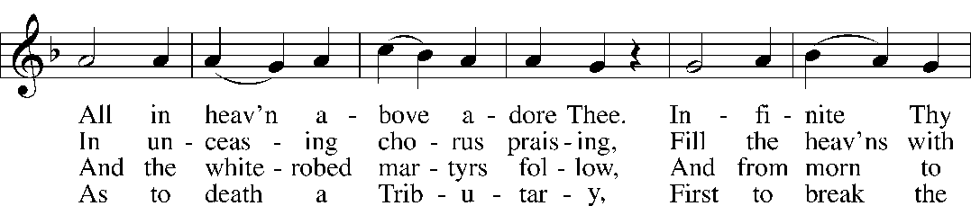
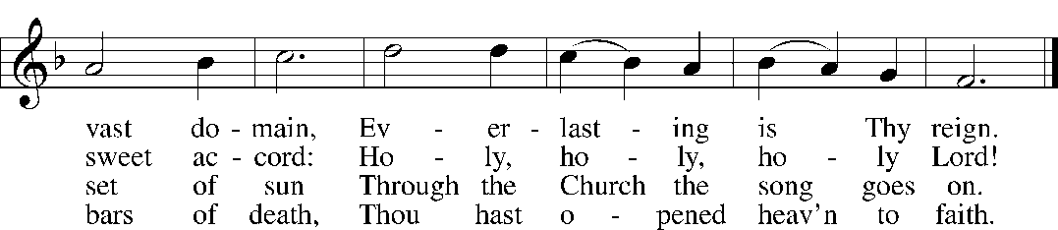

5 Holy Father, holy Son, Holy Spirit, three we name Thee;
Though in essence only one,
Undivided God we claim Thee
And, adoring, bend the knee
While we own the mystery.

6 From Thy high celestial home, Judge of all, again returning,
We believe that Thou shalt come
On that final judgment morning,
When Thy voice shall shake the earth
And the startled dead come forth.

7 Spare Thy people, Lord, we pray, By a thousand snares surrounded;
Keep us without sin today,
Never let us be confounded.
Lo, I put my trust in Thee;
Never, Lord, abandon me.
1
Opening Versicles LSB 219
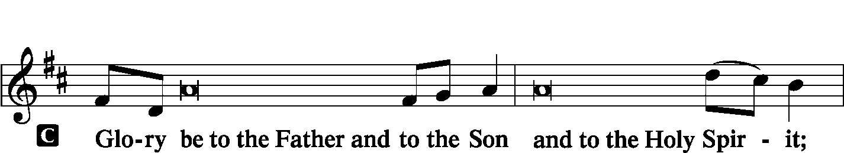
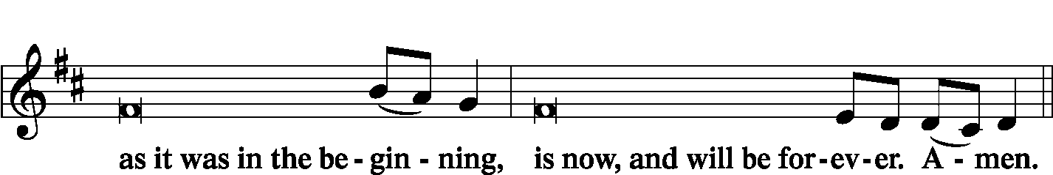
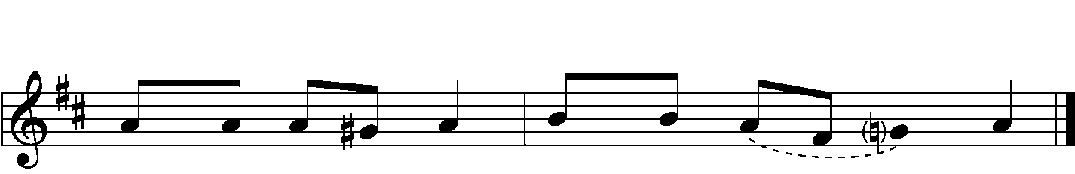

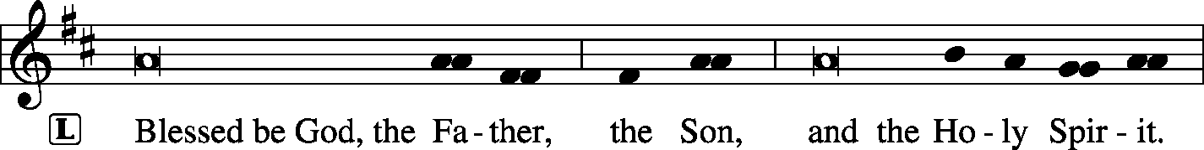

2
Venite LSB 220
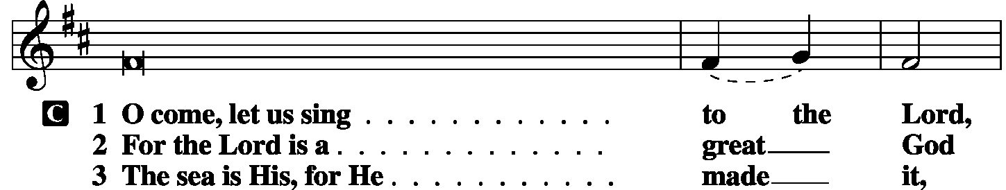
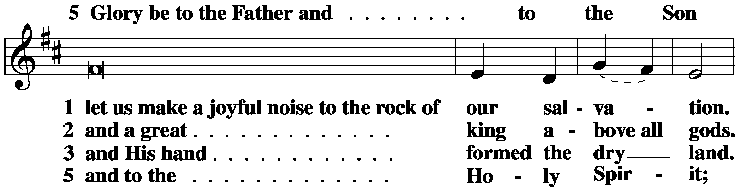
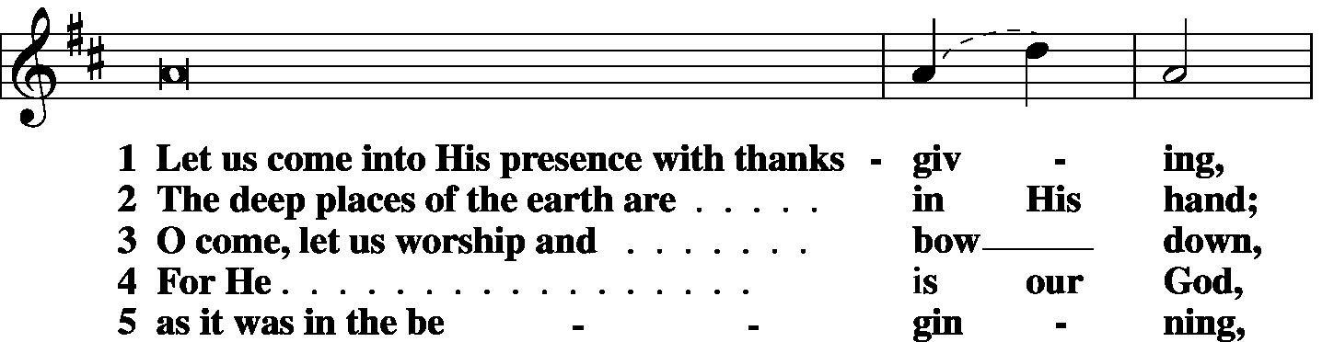
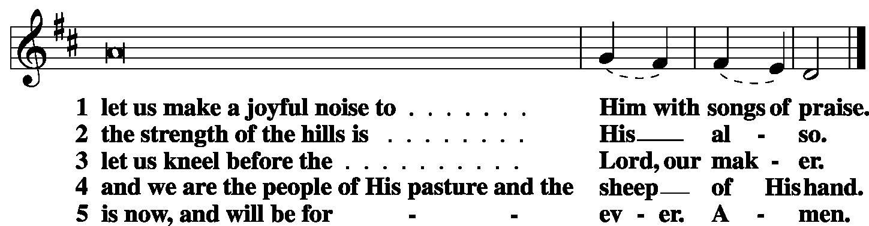

Antiphon (Common) LSB 221

3
Readings for the Seventeenth Sunday after Pentecost
The First Lesson – Ezekiel 18:1-4, 25-32
¹The word of the Lord came to me: ²“What do you mean by repeating this proverb concerning the land of Israel, ‘The fathers have eaten sour grapes, and the children’s teeth are set on edge’? ³As I live, declares the Lord God, this proverb shall no more be used by you in Israel. ⁴Behold, all souls are mine; the soul of the father as well as the soul of the son is mine: the soul who sins shall die.
²⁵“Yet you say, ‘The way of the Lord is not just.’ Hear now, O house of Israel: Is my way not just? Is it not your ways that are not just? ²⁶When a righteous person turns away from his righteousness and does injustice, he shall die for it; for the injustice that he has done he shall die. ²⁷Again, when a wicked person turns away from the wickedness he has committed and does what is just and right, he shall save his life. ²⁸Because he considered and turned away from all the transgressions that he had committed, he shall surely live; he shall not die. ²⁹Yet the house of Israel says, ‘The way of the Lord is not just.’ O house of Israel, are my ways not just? Is it not your ways that are not just?
³⁰“Therefore I will judge you, O house of Israel, every one according to his ways, declares the Lord God. Repent and turn from all your transgressions, lest iniquity be your ruin. ³¹Cast away from you all the transgressions that you have committed, and make yourselves a new heart and a new spirit! Why will you die, O house of Israel? ³²For I have no pleasure in the death of anyone, declares the Lord God; so turn, and live.”

L O Lord, have mercy on us.
C Thanks be to God.

Anthem

The Epistle – Philippians 2:1-4, 14-18
¹So if there is any encouragement in Christ, any comfort from love, any participation in the Spirit, any affection and sympathy, ²complete my joy by being of the same mind, having the same love, being in full accord and of one mind. ³Do nothing from rivalry or conceit, but in humility count others more significant than yourselves. ⁴Let each of you look not only to his own interests, but also to the interests of others.

4
¹⁴Do all things without grumbling or questioning, ¹⁵that you may be blameless and innocent, children of God without blemish in the midst of a crooked and twisted generation, among whom you shine as lights in the world, ¹⁶holding fast to the word of life, so that in the day of Christ I may be proud that I did not run in vain or labor in vain. ¹⁷Even if I am to be poured out as a drink offering upon the sacrificial offering of your faith, I am glad and rejoice with you all. ¹⁸Likewise you also should be glad and rejoice with me.

L O Lord, have mercy on us.
C Thanks be to God.

Responsory
Common LSB 221
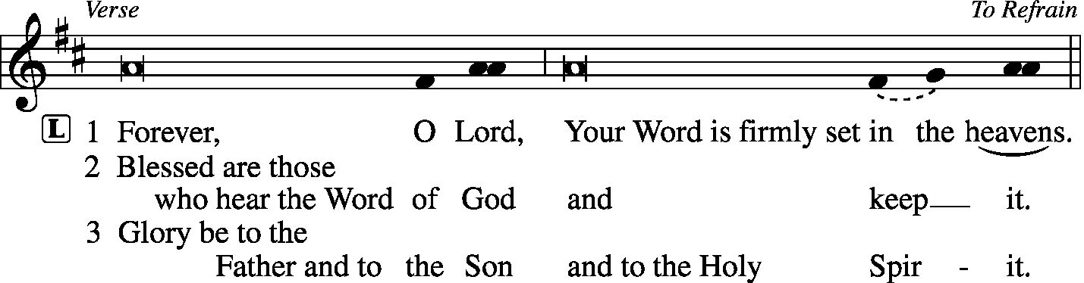
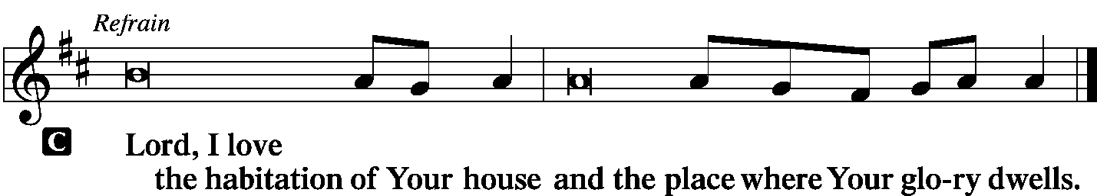

Congregation stands for the Holy Gospel – Matthew 21:23-32
²³ When [Jesus] entered the temple, the chief priests and the elders of the people came up to him as he was teaching, and said, “By what authority are you doing these things, and who gave you this authority?”
²⁴Jesus answered them, “I also will ask you one question, and if you tell me the answer, then I also will tell you by what authority I do these things. ²⁵The baptism of John, from where did it come? From heaven or from man?” And they discussed it among themselves, saying, “If we say, ‘From heaven,’ he will say to us, ‘Why then did you not believe him?’ ²⁶But if we say, ‘From man,’ we are afraid of the crowd, for they all hold that John was a prophet.” ²⁷So they answered Jesus, “We do not know.” And he said to them, “Neither will I tell you by what authority I do these things.

5
²⁸“What do you think? A man had two sons. And he went to the first and said, ‘Son, go and work in the vineyard today.’ ²⁹And he answered, ‘I will not,’ but afterward he changed his mind and went. ³⁰And he went to the other son and said the same. And he answered, ‘I go, sir,’ but did not go. ³¹Which of the two did the will of his father?” They said, “The first.” Jesus said to them, “Truly, I say to you, the tax collectors and the prostitutes go into the kingdom of God before you. ³²For John came to you in the way of righteousness, and you did not believe him, but the tax collectors and the prostitutes believed him. And even when you saw it, you did not afterward change your minds and believe him.

L O Lord, have mercy on us.
C Thanks be to God.

Apostles’ Creed
I believe in God, the Father Almighty, maker of heaven and earth.
And in Jesus Christ, His only Son, our Lord, who was conceived by the Holy Spirit,
born of the virgin Mary, suffered under Pontius Pilate, was crucified, died and was buried.
He descended into hell. The third day He rose again from the dead.
He ascended into heaven and sits at the right hand of God the Father Almighty.
From thence He will come to judge the living and the dead.
I believe in the Holy Spirit, the holy Christian Church, the communion of saints, the forgiveness of sins, the resurrection of the body, and the life everlasting. Amen.

Sermon Hymn 655 Lord, Keep Us Steadfast in Your Word
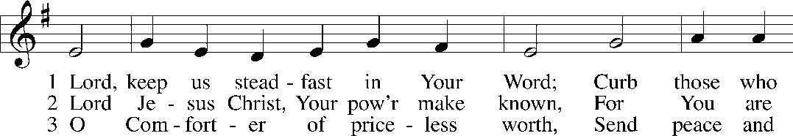
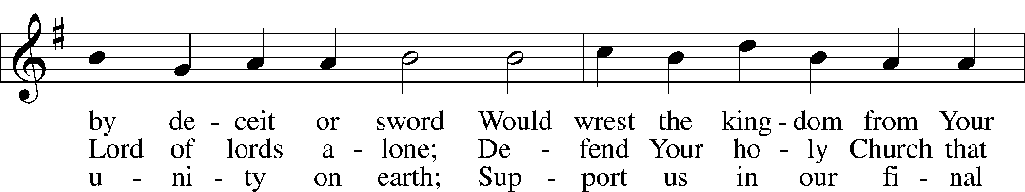

6
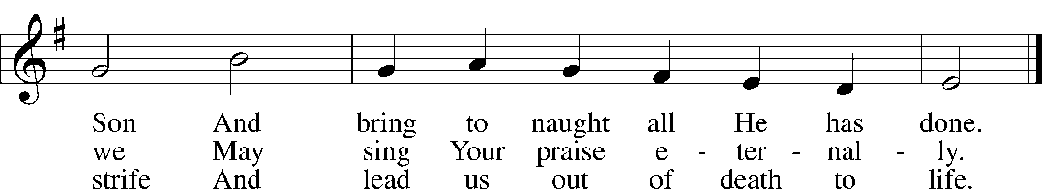

Sermon “The Smother Brother” Matthew 21

Offering

Te Deum

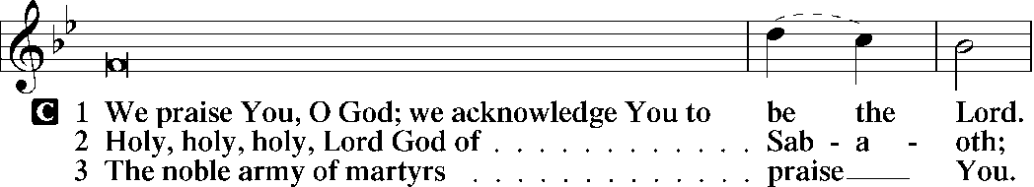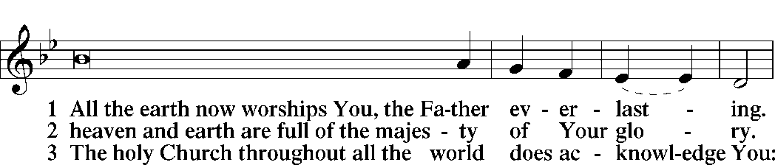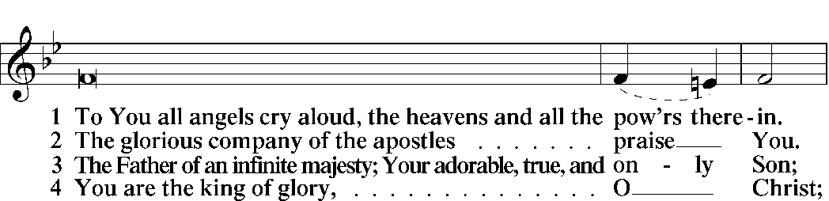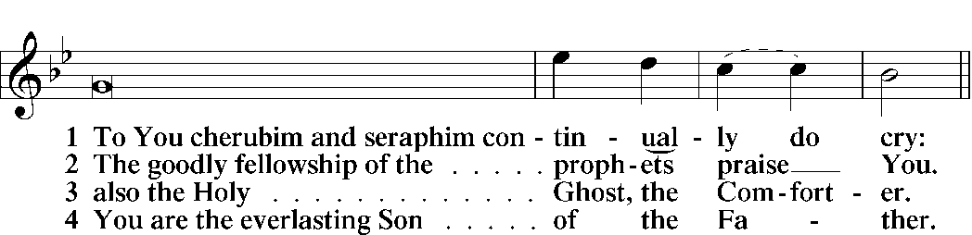

7
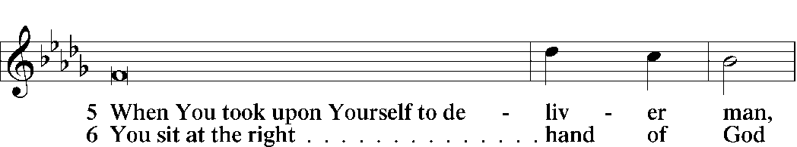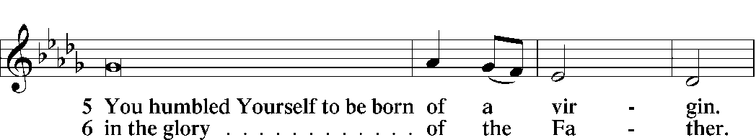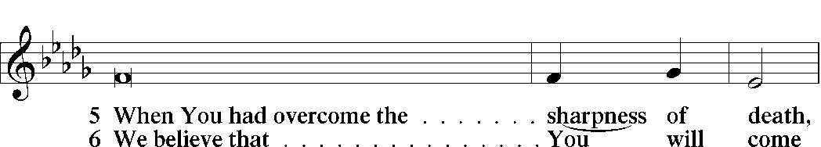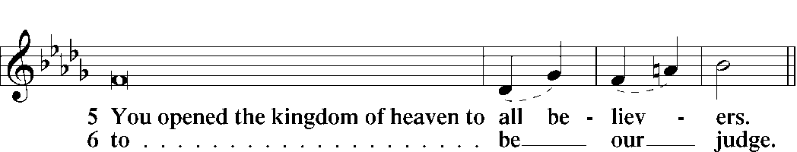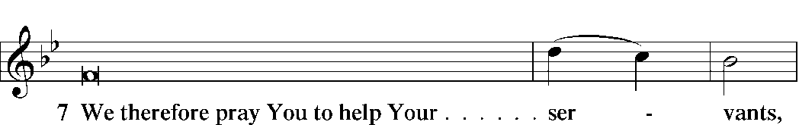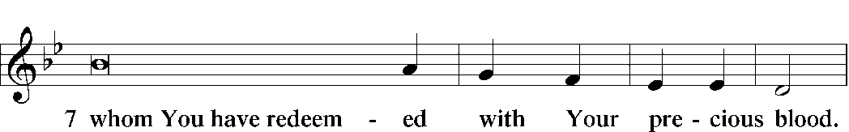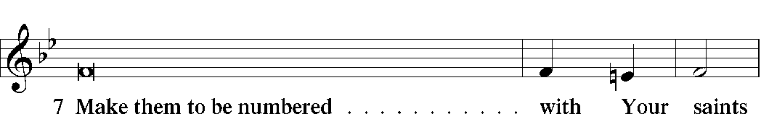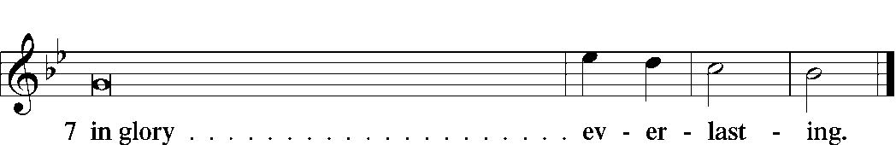
Prayers
Kyrie LSB 227
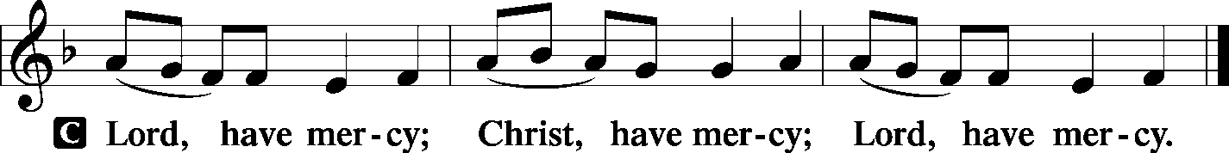
8
Lord's Prayer
C Our Father who art in heaven,
hallowed be Thy name,
Thy kingdom come,
Thy will be done on earth as it is in heaven;
give us this day our daily bread;
and forgive us our trespasses as we forgive those who trespass against us;
and lead us not into temptation,
but deliver us from evil.
For Thine is the kingdom and the power and the glory forever and ever. Amen.

Collects
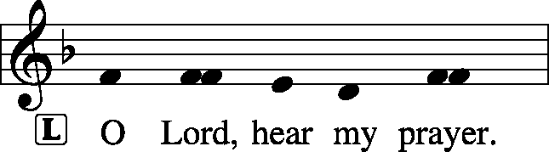
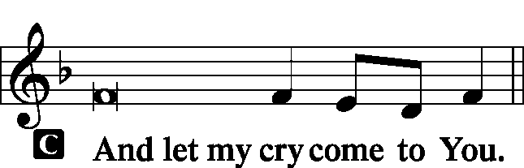

Collect of the Day
Almighty God, You exalted Your Son to the place of all honor and authority. Enlighten our minds by Your Holy Spirit that, confessing Jesus as Lord, we may be led into all truth; through the same Jesus Christ, our Lord, who lives and reigns with You and the Holy Spirit, one God, now and forever.
C Amen.

Additional Collects of Intercession and Thanksgiving
Almighty God, You exalted Your Son to the place of all honor and authority. Enlighten our minds by Your Holy Spirit that, confessing Jesus as Lord, we may be led into all truth; through the same Jesus Christ, our Lord, who lives and reigns with You and the Holy Spirit, one God, now and forever.
C Amen.

Collect for Grace
L O Lord, our heavenly Father, almighty and everlasting God, You have safely brought us to the beginning of this day. Defend us in the same with Your mighty power and grant that this day we fall into no sin, neither run into any kind of danger, but that all our doings, being ordered by Your governance, may be righteous in Your sight; through Jesus Christ, Your Son, our Lord, who lives and reigns with You and the Holy Spirit, one God, now and forever.

9
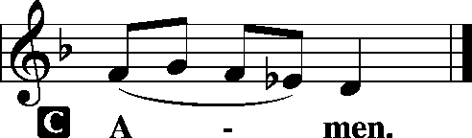

Benedicamus LSB 228
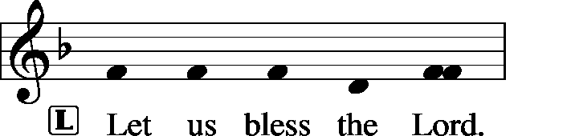
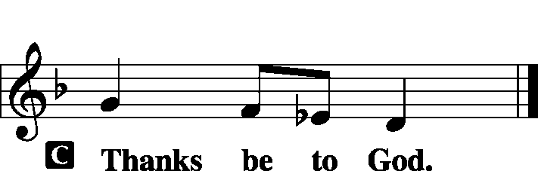

Benediction LSB 234
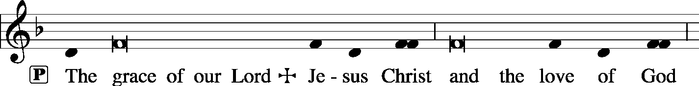
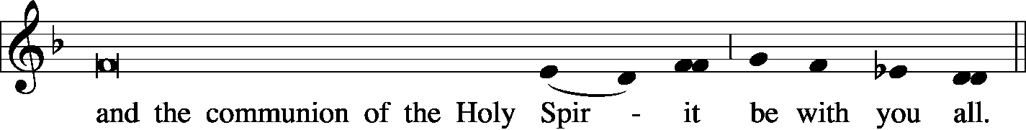
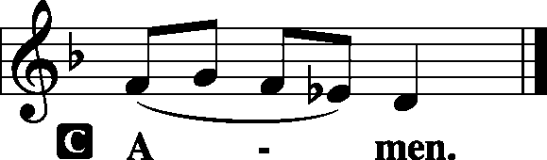

10
Closing Hymn
848 Lord, Whose Love through Humble Service
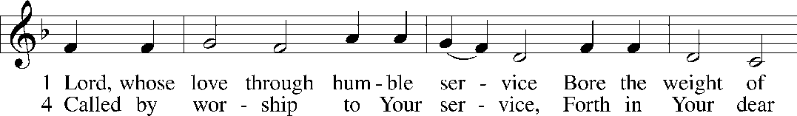
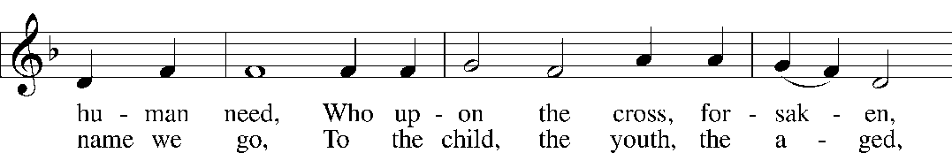
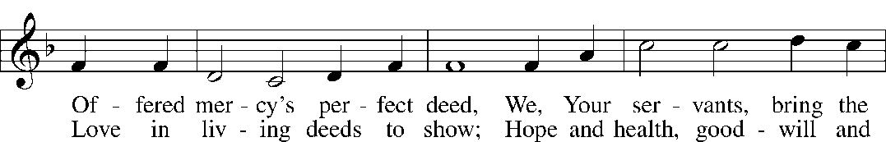
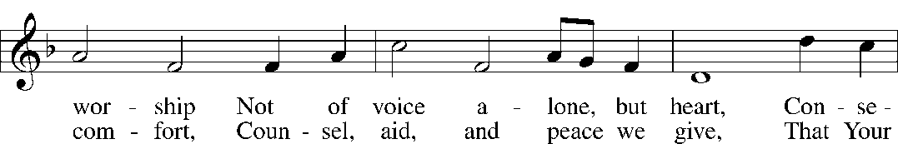
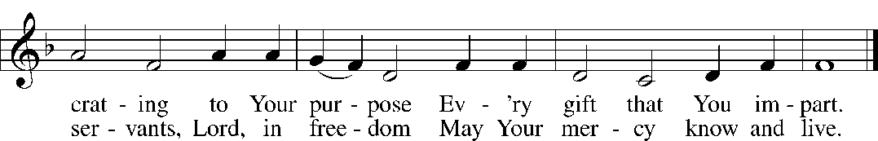
© Oxford University Press. Used by permission: LSB Hymn License .NET, no. 100012738.

Silent Prayer

Announcements

Postlude

Acknowledgments
Matins from Lutheran Service Book
Unless otherwise indicated, all scripture quotations are from The Holy Bible, English Standard Version, copyright © 2001 by Crossway Bibles, a division of Good News Publishers. Used by permission. All rights reserved.
Created by Lutheran Service Builder © 2006 Concordia Publishing House.

11

